A MINI PROJECT REPORT

ON

**“THEFT DETECTION AND ALERTS SYSTEM BY** **USING GSM, GPS & RF SIGNAL”**

***Submitted in partial fulfillment for the award of the degree***

Of

**BACHELOR OF TECHNOLOGY**

IN

**ELECTRONICS AND COMMUNICATION ENGINEERING**

***Submitted By:***

**D.NAVYA MANISHA (12R21A04D3)**

**G.VAMSHI KRISHNA (12R21A04D7)**

**J.RAGHU BABU (12R21A04E0)**

**K.VARUN KUMAR (12R21A04E5)**

**K.SRIKANTH YADAV (12R21A04F4)**

**N.KISHORE KUMAR (12R21A04F9)**

**P.SHIVA KRISHNA (12R21A04G2)**

**P.SHIVA PRASAD (13R25A0412)**

Under the Supervision of

**J.NAGARAJU**

E:\mlr.png

**2016**

**DEPARTMENT OF ELECTRONICS AND COMMUNICATION ENGINEERING**

E:\mlr.png

***CERTIFICATE***

This is to certify that the project work entitled (**THEFT DETECTION AND ALERTS SYSTEM BY** **USING GSM,GPS & RF SIGNAL**)has been submitted in partial fulfillment of the requirement for the award of degree of Bachelor of Technology in **Electronics & Communication Engineering** discipline of JNTU, Hyderabad for the academic year 2016 is a record bonafide work carried out by

**D.NAVYA MANISHA (12R21A04D3)**

**G.VAMSHI KRISHNA (12R21A04D7)**

**J.RAGHU BABU (12R21A04E0)**

**K.VARUN KUMAR (12R21A04E5)**

**K.SRIKANTH YADAV (12R21A04F4)**

**N.KISHORE KUMAR (12R21A04F9)**

**P.SHIVA KRISHNA (12R21A04G2)**

**P.SHIVA PRASAD (13R25A0412)**

**Signature of the guide Signature of the Head of the Department**

Mr.J.NAGARAJU Mr.S.V.S. PRASAD

**External Examiner Principal**

**Acknowledgement**

With the completion of the project, we would like to thank all the people involved in the work.

We are grateful to **Mr.P.Bhaskar Reddy** principal of **Marri Laxman Reddy Institute of Technology**, for granting the permission for the practical training through development of this project. We shall forever cherish our association with him for exuberant encouragement, inspiration and motivation given throughout.

We wish to express our sincere thanks to **Mr.S.V.S. Prasad Head of the Department, Electronics & Communication Engineering**, for guiding us all through our project provoking discussions, invigorating suggestions extended to us with an immense care and zeal.

We have immense pleasure in expressing our thanks and deep sense of gratitude to our guide **Mr.J.NAGARAJU**, for his guidence and assistance offered in an aim able and pleasant manner throughout our project.

We sincerely thank to all the teaching and non-teaching staff of the Department of Electronics & Communication Engineering for their timely suggestions, healthy criticism and motivation during the course of this work.

**D.NAVYA MANISHA (12R21A04D3)**

**G.VAMSHI KRISHNA (12R21A04D7)**

**J.RAGHU BABU (12R21A04E0)**

**K.VARUN KUMAR (12R21A04E5)**

**K.SRIKANTH YADAV (12R21A04F4)**

**N.KISHORE KUMAR (12R21A04F9)**

**P.SHIVA KRISHNA (12R21A04G2)**

**P.SHIVA PRASAD (13R25A0412)**

**DECLARATION**

We hereby declare that this Mini project report entitled **“THEFT DETECTION AND ALERTS SYSTEM BY** **USING GSM,GPS & RF SIGNAL”** has been prepared by us, in partial fulfillment of the requirements for the award of Bachelor of Technology in Electronics & Communication Engineering.

We also declare that this work is a result of our own effort and that it has not been submitted to any other university for the award of any Degree/Diploma.

**D.NAVYA MANISHA (12R21A04D3)**

**G.VAMSHI KRISHNA (12R21A04D7)**

**J.RAGHU BABU (12R21A04E0)**

**K.VARUN KUMAR (12R21A04E5)**

**K.SRIKANTH YADAV (12R21A04F4)**

**N.KISHORE KUMAR (12R21A04F9)**

**P.SHIVA KRISHNA (12R21A04G2)**

**P.SHIVA PRASAD (13R25A0412)**

**INDEX**

|  |  |  |
| --- | --- | --- |
| **CHAPTER 1** | **Contents** | **Page No** |
|  | **Abstract** | **I** |
| 1 | **Introduction** | **1** |
| 1.1 | INTRODUCTION TO GPS AND GSM BASED VEHICLE  TRACKING AND THEFT CONTROL SYSTEM: | 1 |
| 1.2 | INTRODUCTION TO EMBEDDED SYSTEM | 2 |
| 1.3 | LITERATURE SURVEY: | 3 |
| 1.4 | OBJECTIVE: | 4 |
| **CHAPTER 2** | **BLOCK DIAGRAM OF VEHICLE TRACKING AND THEFT**  **CONTROL SYSTEM** | 5 |
| 2.1 | BLOCK DIAGRAM | 5 |
| 2.2 | HARDWARE COMPONENTS | 5 |
| 2.2.1 | GPS | 6 |
| 2.2.1.1. | WORKING OF GPS | 6 |
| 2.2.2. | GSM | 7 |
| 2.2.3. | SERIAL COMMUNICATION | 7 |
| 2.2.3.1. | RS232 CABLE | 10 |
| 2.2.3.2. | MAX 232 | 12 |
| 2.2.4. | LIQUID CRYSTAL DISPLAY – LCD | 13 |
| 2.2.5. | POWER SUPPLY | 15 |
| 2.2.6. | RF TRANSMITTER & RECEIVER | 16 |
| **CHAPTER 3** | **MICROCONTROLLER AT89C51** | 19 |
| 3.1 | FEATURES | 19 |
| 3.2 | PIN DESCRIPTION | 20 |
| 3.3 | SCHEMATIC DIAGRAM | 26 |
| 3.4 | CIRCUIT DESCRIPTION | 27 |
| 3.5 | CIRCUIT OPERATION | 27 |
| 3.6 | POWER SUPPLY | 28 |
| 3.7 | SERIAL PORTS | 28 |
| **CHAPTER 4** | **GSM** | **29** |
| 4.1 | DEFINATION OF GSM | 29 |
| 4.2 | HISTORY | 29 |
| 4.3 | INTRODUCTION | 30 |
| 4.4 | GSM STANDARDS | 31 |
| 4.5 | CONCEPTS OF CELLULAR NETWORK | 33 |
| 4.6 | ARCHITECTURE OF GSM | 33 |
| 4.7 | BAIC CONCEPTS OF SMS TECHNOLOGY | 40 |
| **CHAPTER 5** | **GPS** | **42** |
| 5.1 | OPERATING PRINCPLES | 43 |
| 5.2 | GPS RECIVER SETUP | 44 |
| 5.3 | SPACE SEGMENT | 46 |
| 5.4 | FACTORS AFFECTING GPS | 47 |
| 5.5 | GPS RECEIVER | 50 |
| 5.6 | GPS CALCULATIONS | 51 |
| 5.7 | GPS APPLICATIONS | 53 |
| **CHAPTER 6** | **SOFTWARE IMPLEMENTATION** | **55** |
| 6.1 | KEIL SOFTWARE | 55 |
| 6.2 | PROJECTS | 55 |
| 6.3 | SIMULATOR/DEBUGGER | 56 |
| 6.4 | ARM SOFTWARE | 56 |
| **CHAPTER 7** | **MOBILE APPLICATION** | **63** |
| **CHAPTER 8** | **TESTING** | **68** |
| 8.1 | TEST CASES | 68 |
| 8.2 | APPLICATIONS & ADVANTAGES | 69 |
| 8.3 | RESULT ANALYSIS | 69 |
| 8.4 | CONCLUSION | 71 |
|  | **BIBILOGRAPHY** | 72 |

**CHAPTER-1**

**INTRODUCTION**

**1.1 INTRODUCTION TO GPS AND GSM BASED VEHICLE TRACKING AND THEFT CONTROL SYSTEM:**

In the last few decades, India has progressed at such an enormous rate that many companies have strongly established themselves here. These companies bring a huge amount of workforce with them. Arranging transportation to such a huge mass is a cumbersome task involving many intricacies. Generally, this transport is arranged through the local transport vendors on a yearly contract basis, recently happen mishaps such as burglary, rape cases etc. The development of satellite communication technology is easy to identify the vehicle locations. Vehicle tracking systems have brought this technology to the day-to-day life of the common person. Today GPS used in cars, ambulances, fleets and police vehicles are common sights on the roads of developed countries. All the existing technology support tracking the vehicle place and status.

The GPS/GSM Based System is one of the most important systems, which integrate both GSM and GPS technologies. It is necessary due to the many of applications of both GSM and GPS systems and the wide usage of them by millions of people throughout the world. This system designed for users in land construction and transport business, provides real-time information such as location, speed and expected arrival time of the user is moving vehicles in a concise and easy-to-read format. This system may also useful for communication process among the two points.

Currently GPS vehicle tracking ensures their safety as travelling. This vehicle tracking system found in clients vehicles as a theft prevention and rescue device. Vehicle owner or Police follow the signal emitted by the tracking system to locate a robbed vehicle in parallel the stolen vehicle engine speed going to decreased and pushed to off. After switch of the engine, motor cannot restart without permission of password. This system installed for the four wheelers, Vehicle tracking usually used in navy operators for navy management functions, routing, send off, on board information and security. The applications include monitoring driving performance of a parent with a teen driver. Vehicle tracking systems accepted in consumer vehicles as a theft prevention and retrieval device. If the theft identified, the system sends the SMS to the vehicle owner. After that vehicle owner sends the SMS to the controller, issue the necessary signals to stop the motor.

**1.2. INTRODUCTION TO EMBEDDED SYSTEM:**

An embedded system is a special purpose system in which the computer is completely encapsulated by or dedicated to the device or system it controls. Unlike a general purpose computer, such as a personal computer, an embedded system performs one or few predefined tasks, design engineers can optimize it, reducing the size and cost of the product. Embedded systems are often mass-produced, benefiting from economies of scale.

Personal digital assistants (PDAs) or handled computers are generally considered embedded devices because of the nature of their hardware design, even though they are more expandable in software terms. This line of definition continues to blur as devices expand. With the introduction of the OQO model 2 with the windows XP operating system and ports such as a USB port both features usually belong to “general purpose computers”, the line of nomenclature blurs even more.

In terms of complexity embedded systems can range from very simple with a single microcontroller chip, to very complex with multiple units, peripherals and networks mounted inside a large chassis or enclosure.

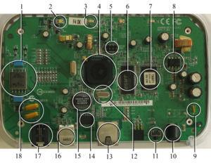

**Figure 1.2.1: Example of Embedded system**

**Examples of Embedded Systems:**

* Avonics, such as inertial guidance systems, flight control hardware/software and other integrated systems in aircraft and missiles.
* Cellular telephones and telephone switches.
* Engine controllers and anticlock brake controllers for automobiles.
* Home automation products, such as thermostats, air conditioners, sprinklers and security monitoring systems.

**1.3. LITERATURE SURVEY:**

Real-time tracking and management of vehicles has been a field of interest for many researchers and a lot of research work has been done for tracking system. Recently the various anti-theft modules like steering wheel locked equipment, network tracking system and traditional electronic alarm are developed along with client identification and real time performance monitoring.

The paper presented by El-Medany, W.; Al-Omary et al describes a real time tracking system that provides accurate localizations of the tracked vehicle with low cost. GM862 cellular quad band module is used for implementation. A monitoring server and a graphical user interface on a website is also developed using Microsoft SQL Server 2003 and ASP.net to view the proper location of a vehicle on a specific map. The paper also provides information regarding the vehicle status such as speed, mileage.

Hu Jian-ming; Li Jie; Li Guang-Hui describes an automobile anti-theft system using GSM and GPS module. The system is developed using high speed mixed type single-chip C8051F120 and stolen automobile is detected by the use of vibration sensor. The system remains in contact with automobile owner through the GSM module, for the safety and reliability of automobile.

Fleischer, P.B.; Nelson et al describes development and deployment of GPS (Global Positioning System)/GSM (Global System for Mobile Communications) based Vehicle Tracking and Alert System. This system allows inter-city transport companies to track their vehicles in real-time and provides security from armed robbery and accident occurrences.

Le-Tien, T.; Vu Phung describes a system based on the Global Positioning System (GPS) and Global System for Mobile Communication (GSM). It describes the practical model for routing and tracking with mobile vehicle in a large area outdoor environment .The system includes the Compass sensor-YAS529 of Yamaha Company and Accelerator sensor-KXSC72050 of Koinix Company to acquire moving direction of a vehicle. The system will acquire positions of the vehicle via GPS receiver and then sends the data to supervised center by the SMS (Short Message Services) or GPRS (General Package Radio Service) service. The supervised center comprises of a development kit that supports GSM techniques-WMP100 of the Wavecom Company. Finally, the position of the mobile vehicle will be displayed on Google Map.

**1.4. OBJECTIVE:**

The main aim of the project is to design and develop an advanced vehicle tracking and locking system in the real time environment. The user can send a STATUS message from his cell phone and as soon as the GSM module gets the message, it will check for the user’s authentication and if found to be valid, it will immediately send the details of the locations like the latitude and the longitude using GPS module. So the user can get to know the exact location of the vehicle. At the same time message will be sent to a mobile where user can get the exact location of vehicle pointed out on the Google maps.In recent years, vehicle thefts are increasing at an alarming rate around the world. People have started to use the vehicle tracking and theft control systems installed in their vehicles. The developed system makes use of an embedded system based GSM/GPS technology(SIMCOM’s SIM300 GSM operates in the 900MHz and 1.8GHz bands GSM supports data transfer speeds of up to 9.6kbps).

Once the vehicle is being stolen, the information is being used by the vehicle owner for further processing. Where by sitting at a remote place, a particular number is dialed by them to interface GSM MODEM that is with the hardware kit which is installed with the vehicle. By reading the signals received by the mobile, the engine is locked automatically and sends the SMS to the dialed number stating the exacting position using GPS modem. Again it will come to the normal condition only after entering a secured password.

The main concept in this design is introducing the GSM and GPS technologies into the embedded system. The designed unit is very simple and low cost. The entire designated unit is on a single chip.

**CHAPTER-2**

**BLOCK DIAGRAM OF VEHICLE TRACKING AND THEFT CONTROL SYSTEM**

**2.1. BLOCK DIAGRAM:**



























**Figure 2.1.1: Block diagram**

**2.2. HARDWARE COMPONENTS:**

* AT89C51
* GPS MODULE
* GSM MODULE
* RS232
* MAX 232
* LCD
* POWER SUPPLY
* RF TRANSMITTER& RECEIVER

In this project AT89C51 microcontroller is used for interfacing to various hardware peripherals. The current design is an embedded application, which will continuously monitor a moving Vehicle and report the status of the Vehicle on demand. For doing so an AT89C51 microcontroller is interfaced serially to a GSM Modem and GPS Receiver. A GSM modem is used to send the position (Latitude and Longitude) of the vehicle from a remote place. The GPS modem will continuously give the data i.e. the latitude and longitude indicating the position of the vehicle. The GPS modem gives many parameters as the output, but only the NMEA data coming out is read and displayed on to the LCD. The same data is sent to the mobile at the other end from where the position of the vehicle is demanded.

The hardware interfaces to microcontroller are LCD display, GSM modem and GPS Receiver. The design uses RS-232 protocol for serial communication between the modems and the microcontroller. A serial driver IC is used for converting TTL voltage levels to RS-232 voltage levels. When the request by user is sent to the number at the modem, the system automatically sends a return reply to that mobile indicating the position of the vehicle in terms of latitude and longitude.

As the Micro Controller, GPS and GSM take a sight of in depth knowledge, they are explained in the next chapters.

**2.2.1. GPS:**

**GPS,** in full Global Positioning System, space-based radio-navigation system that broadcasts highly accurate navigation pulses to users on or near the Earth. In the United States’ Navstar GPS, 24 main satellites in 6 orbits circle the Earth every 12 hours. In addition, Russia maintains a constellation called GLONASS (Global Navigation Satellite System).

**2.2.1.1. WORKING OF GPS:**

GPS receiver works on 9600 baud rate is used to receive the data from space Segment (from Satellites), the GPS values of different Satellites are sent to microcontroller AT89S52, where these are processed and forwarded to GSM. At the time of processing GPS receives only $GPRMC values only. From these values microcontroller takes only latitude and longitude values excluding time, altitude, name of the satellite, authentication etc. E.g. LAT: 1728:2470 LOG: 7843.3089 GSM modem with a baud rate 57600.

A GPS receiver operated by a user on Earth measures the time it takes radio signals to travel from four or more satellites to its location, calculates the distance to each satellite, and from this calculation determines the user’s longitude, latitude, and altitude. The U.S. Department of Defense originally developed the Navstar constellation for military use, but a less precise form of the service is available free of charge to civilian users around the globe. The basic civilian service will locate a receiver within 10 meters (33 feet) of its true location, though various augmentation techniques can be used to pinpoint the location within less than 1 cm (0.4 inch). With such accuracy and the ubiquity of the service, GPS has evolved far beyond its original military purpose and has created a revolution in personal and commercial navigation. Battlefield missiles and artillery projectiles use GPS signals to determine their positions and velocities, but so do the U.S. space shuttle and the International Space Station as well as commercial jetliners and private airplanes. Ambulance fleets, family automobiles, and railroad locomotives benefit from GPS positioning, which also serves farm tractors, ocean liners, hikers, and even golfers. Many GPS receivers are no larger than a pocket calculator and are powered by disposable batteries, while GPS computer chips the size of a baby’s fingernail have been installed in wristwatches, cellular telephones, and personal digital assistants.

**2.2.2. GSM:**

GSM (or Global System for Mobile Communications) was developed in 1990. The first GSM operator has subscribers in 1991, the beginning of 1994 the network based on the standard, already had 1.3 million subscribers, and the end of 1995 their number had increased to 10 million!

There were first generation mobile phones in the 70's, there are 2nd generation mobile phones in the 80's and 90's, and now there are 3rd gen phones which are about to enter the Indian market. GSM is called a 2Nd generation, or 2G communications technology.

In this project it acts as a SMS Receiver and SMS sender. The GSM technical specifications define the different entities that form the GSM network by defining their functions and interface requirements.

**2.2.3. SERIAL COMMUNICATION:**

The main requirements for serial communication are:

* Microcontroller
* PC
* RS 232 cable
* MAX 232 IC
* Hyper Terminal

When the pins PD.0 and PD.1 of microcontroller are set, UART which is inbuilt in the microcontroller will be enabled to start the serial communication.

**TIMERS:**

The 8515 has two timers: Timer 0 and Timer 1. They can be used either as timers to generate a time delay or as counters to count events happening outside the microcontroller. Both Timer 0 and Timer 1 are 16-bit wide. Since the 8515 has an 8-bit architecture, each 16-bit timer is accessed as two separate registers of low byte and high byte. Lower byte register of Timer 0 is TL0 and higher byte is TH0. Similarly lower byte register of Timer1 is TL1 and higher byte register is TH1.

**TMOD (timer mode) REGISTER:**

Both timers 0 and 1 use the same register TMOD to set the various operation modes. TMOD is an 8-bit register in which the lower 4 bits are set aside for Timer 0 and the upper 4 bits for Timer 1. In each case, the lower 2 bits are used to set the timer mode and the upper 2 bits to specify the operation.

**GATE:**

Every timer has a means of starting and stopping. Some timers do this by software, some by hardware and some have both software and hardware controls. The timers in the 8515 have both. The start and stop of the timer are controlled by the way of software by the TR (timer start) bits TR0 and TR1. These instructions start and stop the timers as long as GATE=0 in the TMOD register. The hardware way of starting and stopping the timer by an external source is achieved by making GATE=1 in the TMOD register.

**C/T: COUNTER/TIMER**

Timer or counter selected. Cleared for timer operation and set for counter operation.

**M1** Mode bit 1 **M0** Mode bit 0

**Mode Selection**

**M1 M0 Mode Operating Mode**

0 0 0 13-bit timer mode

8-bit timer/counter THx with TLx as 5-bit

Prescaler

0 1 1 16-bit timer mode

16-bit timer/counters THx and TLx are cascaded

1 0 2 8-bit auto reload timer/counter

THx hold a value that is to be reloaded into

TLx each time it overflows

1 1 3 Split timer mode

The mode used here to generate a time delay is MODE 2.

This mode 2 is an 8-bit timer and therefore it allows only values of 00H to FFH to be loaded into the timer’s register TH. After TH is loaded with the 8-bit value, the 8515 give a copy of it to TL. When the timer starts, it starts to count up by incrementing the TL registers. It counts up until it reaches its limit of FFH. When it rolls over from FFH to 00H, it sets high the TF (timer flag). If Timer 0 is used, TF0 goes high and if Timer 1 is used, TF1 goes high. When the TL registers rolls from FFH to 0 and TF is set to 1, TL is reloaded automatically with the original value kept by the TH register.

**Asynchronous and Synchronous Serial Communication:**

Computers transfer data in two ways: parallel and serial. In parallel data transfers, often 8 or more lines are used to transfer data to a device that is only a few feet away. Although a lot of data can be transferred in a short amount of time by using many wires in parallel, the distance cannot be great. To transfer to a device located many meters away, the serial method is best suitable.

In serial communication, the data is sent one bit at a time. The 8515 has serial communication capability built into it, thereby making possible fast data transfer using only a few wires.

The fact that serial communication uses a single data line instead of the 8-bit data line instead of the 8-bit data line of parallel communication not only makes it cheaper but also enables two computers located in two different cities to communicate over the telephone.

Serial data communication uses two methods, asynchronous and synchronous. The synchronous method transfers a block of data at a time, while the asynchronous method transfers a single byte at a time. With synchronous communications, the two devices initially synchronize themselves to each other, and then continually send characters to stay in sync. Even when data is not really being sent, a constant flow of bits allows each device to know where the other is at any given time. That is, each character that is sent is either actual data or an idle character. Synchronous communications allows faster data transfer rates than asynchronous methods, because additional bits to mark the beginning and end of each data byte are not required. The serial ports on IBM-style PCs are asynchronous devices and therefore only support asynchronous serial communications.

Asynchronous means "no synchronization", and thus does not require sending and receiving idle characters. However, the beginning and end of each byte of data must be identified by start and stop bits. The start bit indicates when the data byte is about to begin and the stop bit signals when it ends. The requirement to send these additional two bits causes asynchronous communication to be slightly slower than synchronous however it has the advantage that the processor does not have to deal with the additional idle characters. There are special IC chips made by many manufacturers for serial data communications. These chips are commonly referred to as UART and USART. The 8515 has a built-in UART.

In the asynchronous method, the data such as ASCII characters are packed between a start and a stop bit. The start bit is always one bit, but the stop bit can be one or two bits.

The start bit is always a 0 (low) and stop bit (s) is 1 (high). This is called framing.

The rate of data transfer in serial data communication is stated as bps (bits per second). Another widely used terminology for bps is baud rate. The data transfer rate of a given computer system depends on communication ports incorporated into that system. And in asynchronous serial data communication, this baud rate is generally limited to 100,000bps. The baud rate is fixed to 9600bps in order to interface with the microcontroller using a crystal of 11.0592 MHz

**2.2.3.1. RS232 CABLE:**

To allow compatibility among data communication equipment, an interfacing standard called RS232 is used. Since the standard was set long before the advent of the TTL logic family, its input and output voltage levels are not TTL compatible. For this reason, to connect any RS232 to a microcontroller system, voltage converters such as MAX232 are used to convert the TTL logic levels to the RS232 voltage levels and vice versa.

**HISTORY OF RS 232:**

RS-232 was first introduced in 1962. The original DTEs were electromechanical tele type writers modems electronic terminals, and the original DCEs were (usually) . When (smart and dumb) began to be used, they were often designed to be interchangeable with teletypewriters, and so supported RS-232. The C revision of the standard was issued in 1969 in part to accommodate the electrical characteristics of these devices.

Since application to devices such as computers, printers, test instruments, and so on was not considered by the standard, designers implementing an RS-232 compatible interface on their equipment often interpreted the requirements idiosyncratically. Common problems were non-standard pin assignment of circuits on connectors, and incorrect or missing control signals. The lack of adherence to the standards produced a thriving industry of breakout boxes, patch boxes, test equipment, books, and other aids for the connection of disparate equipment. A common deviation from the standard was to drive the signals at a reduced voltage. Some manufacturers therefore built transmitters that supplied +5 V and -5 V and labeled them as "RS-232 compatible".

Later personal computers serial communications modem (and other devices) started to make use of the standard so that they could connect to existing equipment. For many years, an RS-232-compatible port was a standard feature for , such as connections, on many computers. It remained in widespread use into the late 1990s. In personal computer peripherals, it has largely been supplanted by other interface standards, such as USB.RS 232 is still used to connect older designs of peripherals, industrial equipment (such as PLCs), console ports, and special purpose equipment, such as a cash drawer for a cash register.

The standard has been renamed several times during its history as the sponsoring organization changed its name, and has been variously known as EIA RS-232, EIA 232, and most recently as TIA 232. The standard continued to be revised and updated by the Electronic Industries Alliance Telecommunications Industry Association [3] CCITT and since 1988 by the (TIA).Revision C was issued in a document dated August 1969. Revision D was issued in 1986. The current revision is *TIA-232-F Interface between Data Terminal Equipment and Data Circuit-Terminating Equipment Employing Serial Binary Data Interchange*, issued in 1997. Changes since Revision C have been in timing and details intended to improve harmonization with the standard V.24, but equipment built to the current standard will interoperate with older versions.

Related ITU-T standards include V.24 (circuit identification) and V.28 (signal voltage and timing characteristics).

**LIMITATION OF STANDARD:**

Because the application of RS-232 has extended far beyond the original purpose of interconnecting a terminal with a modem, successor standards have been developed to address the limitations.

Issues with the RS-232 standard include:

* The large voltage swings and requirement for positive and negative supplies increases power consumption of the interface and complicates power supply design. The voltage swing requirement also limits the upper speed of a compatible interface.
* Single-ended signaling referred to a common signal ground limits the noise immunity and transmission distance.
* Multi-drop connection among more than two devices is not defined. While multi-drop "work-around" have been devised, they have limitations in speed and compatibility.
* Asymmetrical definitions of the two ends of the link make the assignment of the role of a newly developed device problematic; the designer must decide on either a DTE-like or DCE-like interface and which connector pin assignments to use.
* The handshaking and control lines of the interface are intended for the setup and take-down of a dial-up communication circuit; in particular, the use of handshake lines for flow control is not reliably implemented in many devices.
* No method is specified for sending power to a device. While a small amount of current can be extracted from the DTR and RTS lines, this is only suitable for low power devices such as mice.
* The 25-way connector recommended in the standard is large compared to current practice.

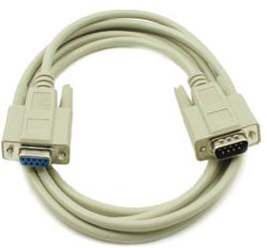

**Figure2.2.3.1.1:RS232 Cable**

**2.2.3.2. MAX 232:**

Max232 IC is a specialized circuit which makes standard voltages as required by RS232 standards. This IC provides best noise rejection and very reliable against discharges and short circuits. MAX232 IC chips are commonly referred to as line drivers. To ensure data transfer between PC and microcontroller, the baud rate and voltage levels of Microcontroller and PC should be the same. The voltage levels of microcontroller are logic1 and logic 0 i.e., logic 1 is +5V and logic 0 is 0V. But for PC, RS232 voltage levels are considered and they are: logic 1 is taken as -3V to -25V and logic 0 as +3V to +25V. So, in order to equal these voltage levels, MAX232 IC is used. Thus this IC converts RS232 voltage levels to microcontroller voltage levels and vice versa.

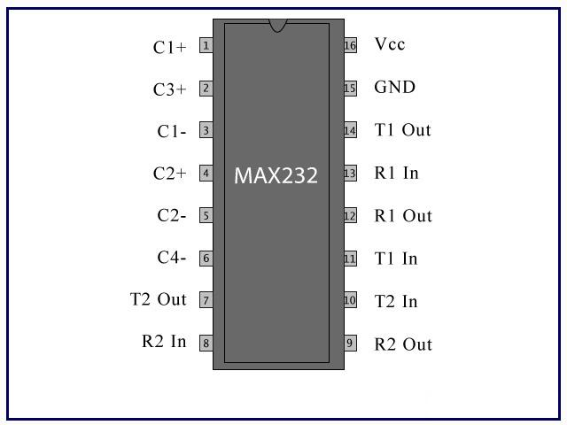

**Figure 2.2.3.2.1: Pin Diagram of MAX232 IC**

**2.2.4. LIQUID CRYSTAL DISPLAY – LCD:**

LCD stands for Liquid Crystal Display. LCD is finding wide spread use replacing LEDs (seven segment LEDs or other multi segment LEDs) because of the following reasons:

1. The declining prices of LCDs.
2. The ability to display numbers, characters and graphics. This is in contrast to LEDs, which

are limited to numbers and a few characters.

1. Incorporation of a refreshing controller into the LCD, thereby relieving the CPU of the

task of refreshing the LCD. In contrast, the LED must be refreshed by the CPU to keep

Displaying the data.

1. Ease of programming for characters and graphics.

These components are “specialized” for being used with the microcontrollers, which means that they cannot be activated by standard IC circuits. They are used for writing different messages on a miniature LCD.

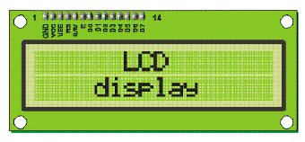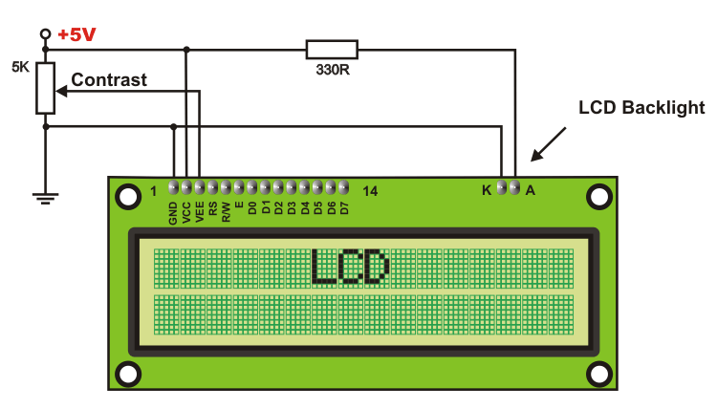

**Figure2.2.4.1: A general purpose alphanumeric LCD, with two lines of 16 characters**

A model described here is for its low price and great possibilities most frequently used in practice. It displays all the alphabets, Greek letters, punctuation marks, mathematical symbols etc. In addition, it is possible to display symbols that user makes up on its own. Automatic shifting message on display (shift left and right), appearance of the pointer, backlight etc. are considered as useful characteristics. I

**ADVANTAGES AND DISADVANTAGES:**

In spite of LCDs being a well proven and still viable technology, as display devices LCDs are not perfect for all applications.

**Advantages:**

* Very compact and light.
* Low power consumption.
* No geometric distortion.
* Little or no flicker depending on back light technology.
* Not affected by screen burn-in.
* Can be made in almost any size or shape.
* No theoretical resolution limit.

**Disadvantages:**

* Limited viewing angle, causing color, saturation, contrast and brightness to vary, even within

the intended viewing angle, by variations in posture.

* Bleeding and uneven backlighting in some monitors, causing brightness distortion, especially toward the edges.
* Smearing and ghosting artifacts caused by slow response times (>8 ms) and "sample and hold" operation.
* Fixed bit depth, many cheaper LCDs are only able to display 262,000 colors. 8-bit S-IPS panels can display 16 million colors and have significantly better black level, but are expensive and have slower response time.
* Low bit depth results in images with unnatural or excessive contrast.
* Input lag.
* Dead or stuck pixels may occur during manufacturing or through use.

**2.2.5. POWER SUPPLY:**

The power supplies are designed to convert high voltage AC mains electricity to a suitable low voltage supply for electronic circuits and other devices. A power supply can by broken down into a series of blocks, each of which performs a particular function. A d.c power supply which maintains the output voltage constant irrespective of a.c mains fluctuations or load variations is known as “Regulated D.C Power Supply”.

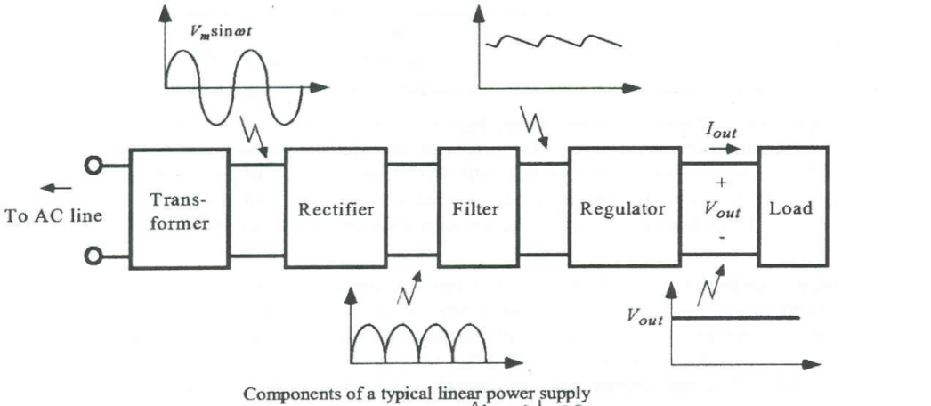

**Figure 2.2.5.1: Block Diagram of power supply**

**VOLTAGE REGULATOR:**

Voltage regulator ICs is available with fixed (typically 5, 12 and 15V) or variable output voltages. The maximum current they can pass also rates them. Negative voltage regulators are available, mainly for use in dual supplies. Most regulators include some automatic protection from excessive Current ('overload protection') and overheating ('thermal protection'). Many of the fixed voltage regulator ICs has 3 leads and look like power transistors, such as the 7805 +5V 1A regulator shown on the right. The LM7805 is simple to use. You simply connect the positive lead of your unregulated DC power supply (anything from 9VDC to 24VDC) to the Input pin, connect the negative lead to the Common pin and then when you turn on the power, you get a 5 volt supply from the output pin.

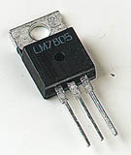

**Figure 2.2.5.2: Voltage Regulator(LM7805)**

**2.2.6. RF TRANSMITTER AND RECEIVER:**

Transmission through RF is better than IR (infrared) because of many reasons. Firstly, signals through RF can travel through larger distances making it suitable for long range applications. Also, while IR mostly operates in line-of-sight mode, RF signals can travel even when there is an obstruction between transmitter & receiver. Next, RF transmission is more strong and reliable than IR transmission. RF communication uses a specific frequency unlike IR signals which are affected by other IR emitting sources.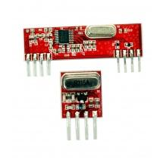

This RF module comprises of an RF Transmitter and an RF Receiver. The transmitter/receiver (Tx/Rx) pair operates at a frequency of 433 MHz an RF transmitter receives serial data and transmits it wirelessly through RF through its antenna connected at pin4. The transmission occurs at the rate of 1Kbps - 10Kbps.The transmitted data is received by an RF receiver operating at the same frequency as that of the transmitter.

Pin Description:

RF Transmitter

|  |  |  |
| --- | --- | --- |
| Pin No | Function | Name |
| 1 | Ground (0V) | Ground |
| 2 | Serial data input pin | Data |
| 3 | Supply voltage; 5V | Vcc |
| 4 | Antenna output pin | ANT |

RF Receiver

|  |  |  |
| --- | --- | --- |
| Pin No | Function | Name |
| 1 | Ground (0V) | Ground |
| 2 | Serial data output pin | Data |
| 3 | Linear output pin; not connected | NC |
| 4 | Supply voltage; 5V | Vcc |
| 5 | Supply voltage; 5V | Vcc |
| 6 | Ground (0V) | Ground |
| 7 | Ground (0V) | Ground |
| 8 | Antenna input pin | ANT |

**SPECIFIACTIONS:**

* Frequency: 433MHz.
* Modulation: ASK
* Receiver Data Output: High - 1/2 Vcc, Low - 0.7v
* Transmitter Input Voltage: 3-12V (high voltage = more transmitting power)
* Receiver Input Voltage : 3.3-6V (high voltage = more receiving power

**CHAPTER-3**

**MICROCONTROLLER AT89C51**

**ATMEL 89C51 MICROCONTROLLER:**

**3.1. FEATURES:**

* Compatible with MCS-51Ô Products
* 4 Kbytes of In-System Reprogrammable Flash Memory

Endurance: 1,000 Write/Erase Cycles

* Fully Static Operation: 0 Hz to 24 MHz
* Three-Level Program Memory Lock
* 128 x 8-Bit Internal RAM
* 32 Programmable I/O Lines
* Two 16-Bit Timer/Counters
* Six Interrupt Sources
* Programmable Serial Channel
* Low Power Idle and Power Down Modes

**DESCRIPTION:**

The AT89C51 is a low-power, high-performance CMOS 8-bit microcomputer with 4Kbytes of Flash Programmable and Erasable Read Only Memory (PEROM). The device is manufactured using Atmel’s high density nonvolatile memory technology and is compatible with the industry standard MCS-51Ô instruction set and pinout. The on-chip Flash allows the program memory to be reprogrammed in-system or by a conventional nonvolatile memory programmer. By combining a versatile 8-bit CPU with Flash on a monolithic chip, the Atmel AT89C51 is a powerful microcomputer which provides a highly flexible and cost effective solution to many embedded control applications.

The AT89C51 provides the following standard features: 4Kbytes of Flash, 128 bytes of RAM, 32 I/O lines, two 16-bit timer/counters, five vector two-level interrupt architecture, a full duplex serial port, and on-chip oscillator and clock circuitry. In addition, the AT89C51 is designed with static logic for operation down to zero frequency and supports two software selectable power saving modes. The Idle Mode stops the CPU while allowing the RAM, timer/counters, serial port and interrupt system to continue functioning. The Power Down Mode saves the RAM contents but freezes the oscillator disabling all other chip functions until the next hardware reset.

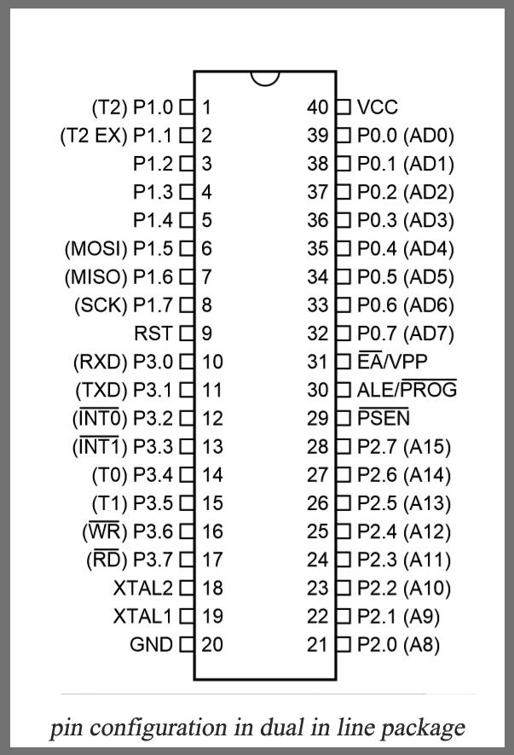

**Figure 3.1.1: Pin Diagram of AT89C51 Micro Controller**

**3.2. PIN DESCRIPTION:**

1. VCC
2. Supply voltage.

3. GND

**Port 0:**

Port 0 is an 8-bit open drain bidirectional I/O port. As an output port, each pin can sink eight TTL inputs. When 1s are written to port 0 pins, the pins can be used as high-impedance inputs. Port 0 can also be configured to be the multiplexed low-order address/data bus during accesses to external program and data memory. In this mode, P0 has internal pull-ups. Port 0 also receives the code bytes during Flash programming and outputs the code bytes during program verification.

**Port 1**:

Port 1 is an 8-bit bidirectional I/O port with internal pull-ups. The Port 1 output buffers can sink/source four TTL inputs. When 1s are written to Port 1 pins, they are pulled high by the internal pull-ups and can be used as inputs. As inputs, Port 1 pins that are externally being pulled low will source current (IIL) because of the internal pull-ups. In addition, P1.0 and P1.1 can be configured to be the timer/counter 2 external count input (P1.0/T2) and the timer/counter 2 trigger input (P1.1/T2EX), respectively, as shown in the following table. Port 1 also receives the low-order address bytes during Flash programming and verification.

|  |  |
| --- | --- |
| **Port pin** | **Alternate Functions** |
| P1.0 | T2 (external count input to timer/counter 2)  Clock-out |
| P1.1 | T2EX (timer/counter 2 capture/reload trigger and direction control) |
| P1.5 | MOSI(used for In-System programming) |
| P1.6 | MISO(used for In-system programming) |
| P1.7 | SCK(used for In-system programming) |

**Table 3.2.1: Port 1 pin functions**

**Port 2:**

Port 2 Port 2 is an 8-bit bidirectional I/O port with internal pull-ups.The Port 2 output buffers can sink/source four TTL inputs. When 1s are written to Port 2 pins, they are pulled high by the internal pull-ups and can be used as inputs. As inputs, Port 2 pins that are externally being pulled low will source current (IIL) because of the internal pull-ups. Port 2 emits the high-order address byte during fetches from external program memory and during accesses to external data memory that use 16-bit addresses (MOVX @ DPTR). In this application, Port 2 uses strong internal pull-ups when emitting 1s. During accesses to external data memory that use 8-bit addresses (MOVX @ RI), Port 2 emits the contents of the P2 Special Function Register. Port 2 also receives the high-order address bits and some control signals during Flash programming and verification. Port Pin Alternate Functions P1.0 T2 (external count input to Timer/Counter 2), clock-out P1.1 T2EX (Timer/Counter 2 capture/reload trigger and direction control) P1.5 MOSI (used for In-System Programming) .

**Port 3:**

Port 3 is an 8-bit bidirectional I/O port with internal pull-ups. The Port 3 output buffers can sink/source four TTL inputs. When 1s are written to Port 3 pins, they are pulled high by the internal pull-ups and can be used as inputs. As inputs, Port 3 pins that are externally being pulled low will source current (IIL) because of the pull-ups. Port 3 receives some control signals for Flash programming and verification. Port 3 also serves the functions of various special features of the AT89S52, as shown in the following table.

|  |  |
| --- | --- |
| **PORT PIN** | **ALTERNATE FUNCTIONS** |
| P3.0 | RXD (serial input port) |
| P3.1 | TXD (serial output port) |
| P3.2 | (external interrupt 1) |
| P3.3 | (external interrupt 0) |
| P3.4 | T0 (timer 0 external input) |
| P3.5 | T1(timer 1 external input) |
| P3.6 | (external data memory write strobe) |
| P3.7 | (external data memory read strobe) |

**Table 3.2.2: Port 3 pin function**

**RST**

Reset input. A high on this pin for two machine cycles while the oscillator is running resets the device.

**ALE/PROG**

Address Latch Enable output pulse for latching the low byte of the address during accesses to external memory. This pin is also the program pulse input (PROG) during Flash programming.

In normal operation ALE is emitted at a constant rate of 1/6 the oscillator frequency, and may be used for external timing or clocking purposes. Note, however, that one ALE pulse is skipped during each access to external Data Memory.

If desired, ALE operation can be disabled by setting bit 0 of SFR location 8EH. With the bit set, ALE is active only during a MOVX or MOVC instruction. Otherwise, the pin is weakly pulled high. Setting the ALE-disable bit has no effect if the microcontroller is in external execution mode.

**PSEN:**

Program Store Enable is the read strobe to external program memory. When the AT89C51 is executing code from external program memory, PSEN is activated twice each machine cycle, except that two PSEN activations are skipped during each access to external data memory.

**EA/VPP:**

External Access Enable. EA must be strapped to GND in order to enable the device to fetch code from external program memory locations starting at 0000H up to FFFFH. Note, however, that if lock bit 1 is programmed, EA will be internally latched on reset. EA should be strapped to VCC for internal program executions. This pin also receives the 12-volt programming enable voltage (VPP) during Flash programming, for parts that require 12-volt VPP.

**XTAL1:**

Input to the inverting oscillator amplifier and input to the internal clock operating circuit.

**XTAL2:**

Output from the inverting oscillator amplifier.

**CRYSTAL OSCILLATOR:**

A **crystal oscillator** is an electronic oscillator circuit that uses the mechanical resonance of a vibrating crystal of piezoelectric material to create an electrical signal with a very precise frequency. This frequency is commonly used to keep track of time (as in quartz wristwatches), to provide a stable clock signal for digital integrated circuits and to stabilize frequencies for radio transmitters and receivers. The most common type of piezoelectric resonator used is the quartz crystal, so oscillator circuits incorporating them became known as crystal oscillators but other piezoelectric materials including polycrystalline ceramics are used in similar circuits. Quartz crystals are manufactured for frequencies from a few tens of kilohertz to hundreds of megahertz. More than two billion crystals are manufactured annually. Most are used for consumer devices such as wristwatches, clocks, radios, computers and cell phones. Quartz crystals are also found inside test and measurement equipment, such as counters, signal generators, and oscilloscopes.

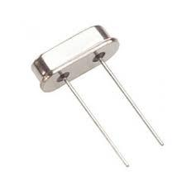

**Figure 3.2.1: Crystal Oscillator**

This image show an 8MHz crystal oscillator commonly used in microcontrollers and microprocessors. Although the crystal has electro-mechanical resonance, we can represent the crystal action by an equivalent electrical resonant circuit as show below. The inductance and capacitance L1 and C1 represents electrical equivalents of crystal mass and compliance, while the resistance R1 represents the friction of crystal’s internal structure and C0 represents the capacitance formed due to mechanical molding of the crystal.

**OSCILLATOR CHARACTERISTICS:**

XTAL1 and XTAL2 are the input and output, respectively, of an inverting amplifier which can be configured for use as an on-chip oscillator, as shown in Figure 1. Either a quartz crystal or ceramic resonator may be used. To drive the device from an external clock source, XTAL2 should be left unconnected while XTAL1 is driven .There are no requirements on the duty cycle of the external clock signal, since the input to the internal clocking circuitry is through a divide-by-two flip-flop, but minimum and maximum voltage high and low time specifications must be observed.

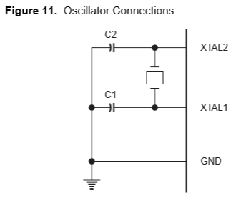

**Figure 3.2.2: Oscillator Connections**

**IDLE MODE:**

In idle mode, the CPU puts itself to sleep while all the on-chip peripherals remain active. The mode is invoked by software. The content of the on-chip RAM and all the special functions registers remain unchanged during this mode. The idle mode can be terminated by any enabled interrupt or by a hardware reset. It should be noted that when idle is terminated by a hardware reset, the device normally resumes program execution, from where it left off, up to two machine cycles before the internal reset algorithm takes control. On-chip hard-ware inhibits access to internal RAM in this event, but access to the port pins is not inhibited. To eliminate the possibility of an unexpected write to a port pin when Idle is terminated by reset, the instruction following the one that invokes Idle should not be one that writes to a port pin or to external memory.

**POWER DOWN MODE:**

In the power down mode the oscillator is stopped, and the instruction that invokes power down is the last instruction executed. The on-chip RAM and Special Function Registers retain their values until the power down mode is terminated. The only exit from power down is a hardware reset. Reset redefines the SFRs but does not change the on chip RAM. The reset should not be activated before VCC is restored to its normal operating level and must be held active long enough to allow the oscillator to restart and stabilize.

**TABLE 3.2.3: STATUS OF EXTERNAL PINS DURING IDLE AND POWER DOWN**

|  |  |  |  |  |  |  |  |
| --- | --- | --- | --- | --- | --- | --- | --- |
| **Mode** | **Program**  **memory** | **ALE** | **PSEN** | **PORT0** | **PORT1** | **PORT2** | **PORT3** |
| Idle | Internal | 1 | 1 | Data | Data | Data | Data |
| Idle | External | 1 | 1 | Float | Data | Address | Data |
| Power Down | Internal | 0 | 0 | Data | Data | Data | Data |
| Power Down | External | 0 | 0 | Float | Data | Data | Data |

**3.3. SCHEMATIC DIAGRAM OF VEHICLE TRACKING AND THEFT CONTROL SYSTEM:**

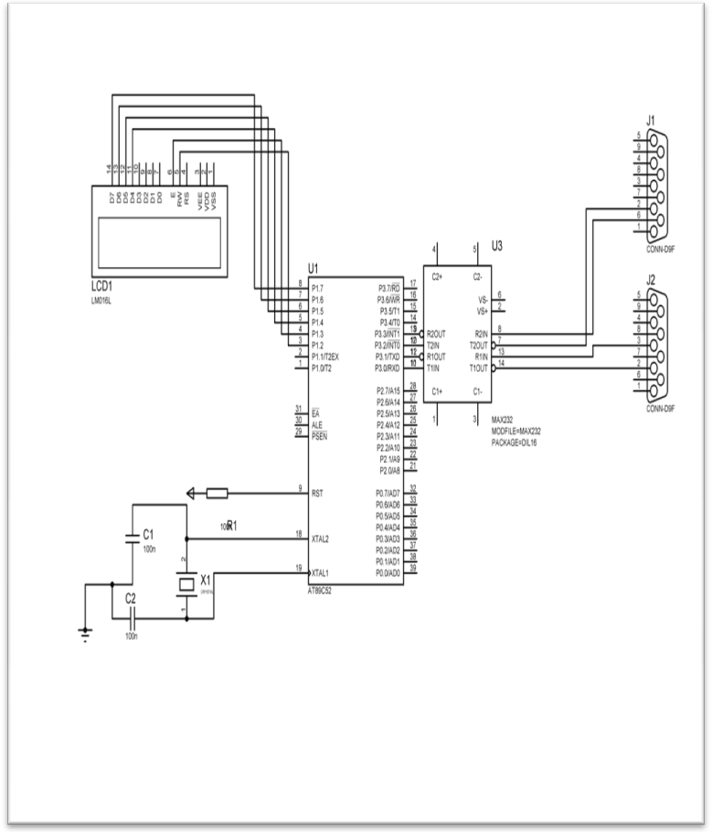

**Figure 3.3.1: INTERFACING OF MICROCONTOLLER WITH GSM&GPS**

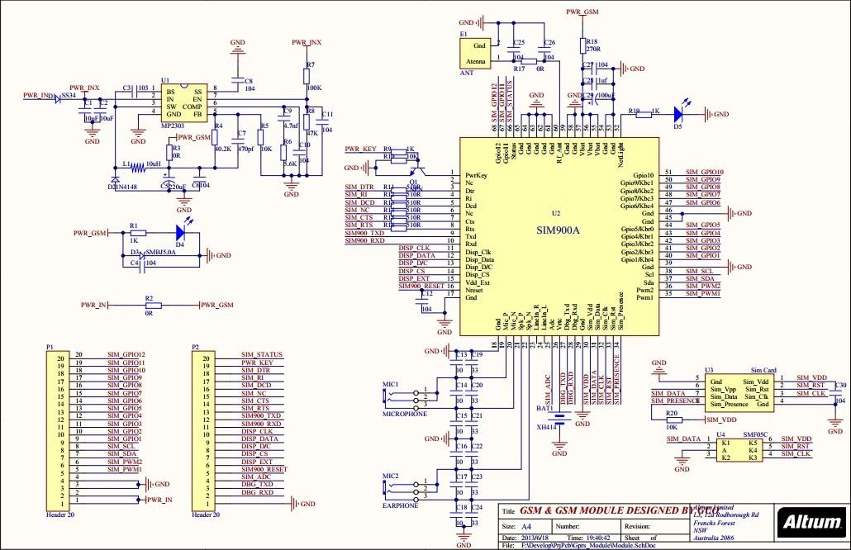

**Figure 3.3.2: GSM**

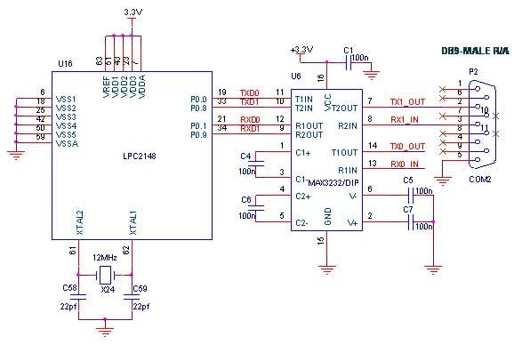

**Figure 3.3.3: GPS**

**3.4. CIRCUIT DESCRIPTION:**

The hardware interfaces to microcontroller are LCD display, GSM modem and GPS receiver. The design uses RS-232 protocol for serial communication between the modems and the microcontroller. A serial driver IC is used for converting TTL voltage levels to RS-232 voltage levels.

When the request is sent by the number at the modem, the system automatically sends a return reply to that mobile indicating the position of the vehicle in terms of latitude and longitude.

**3.5. CIRCUIT OPERATION:**

We are using transmitter and receiver for theft detection.

* Initially there will be continuous transmission between transmitter and receiver. Here transmitter is used as a keychain.
* When the tractor is theft we get alert by using GSM.
* Where GSM is used for transmission of data
* Where we can get an alert saying that our vehicle has been theft to our mobile
* By using GPS we can get latitude and longitude so that we can track our vehicle.
* Here we can send an sms by both from mobile and application directly saying command STOP then the vehicle gets stopped and there will be continuous beep sound such that alert surrounding people.
* We even get an acknowledge message that vehicle has been stopped successfully.
* Then after tracking the vehicle we can start the vehicle by sending command START to GSM
* We include everything in the app, where we added extra feature where by pressing the command start, stop, trace and alert we start, stop and alert to nearest persons and friends ,we can trace our vehicle from App into google maps.

**3.6. POWER:**

The power is supplied to components like GSM, GPS and Micro control circuitry using a 12V/3.2A battery .GSM requires 12v,GPS and microcontroller requires 5v .with the help of regulators we regulate the power between three components.

**3.7. SERIAL PORTS:**

Microcontroller communicates with the help of serial communication. First it takes the data from the GPS receiver and then sends the information to the owner in the form of SMS with help of GSM modem.

**CHAPTER-4**

**GSM TECHNOLOGY**

**4.1 Definition of GSM:**

* GSM (Global System for Mobile communications) is an open, digital cellular technology used for transmitting mobile voice and data services.
* GSM (Global System for Mobile communication) is a digital mobile telephone system that is widely used in Europe and other parts of the world. GSM uses a variation of Time Division Multiple Access (TDMA) and is the most widely used of the three digital wireless telephone technologies (TDMA, GSM, and CDMA). GSM digitizes and compresses data, then sends it down a channel with two other streams of user data, each in its own time slot. It operates at either the 900 MHz or 1,800 MHz frequency band. It supports voice calls and data transfer speeds of up to 9.6 Kbit/s, together with the transmission of SMS (Short Message Service).

**4.2 History:**

In 1982, the European Conference of Postal and Telecommunications Administrations (CEPT) created the Group Special Mobile (GSM) to develop a standard for a mobile telephone system that could be used across Europe. In 1987, a memorandum of understanding was signed by 13 countries to develop a common cellular telephone system across Europe. Finally the system created by SINTEF lead by Torleiv Maseng was selected.

In 1989, GSM responsibility was transferred to the European Telecommunications Standards Institute (ETSI) and phase I of the GSM specifications were published in 1990. The first GSM network was launched in 1991 by Radiolinja in Finland with joint technical infrastructure maintenance from Ericsson.

By the end of 1993, over a million subscribers were using GSM phone networks being operated by 70 carriers across 48 countries. As of the end of 1997, GSM service was available in more than 100 countries and has become the defacto standard in Europe and Asia.

GSM Frequencies GSM networks operate in a number of different frequency ranges (separated into GSM frequency ranges for 2G and UMTS frequency bands for 3G). Most 2G GSM networks operate in the 900 MHz or 1800 MHz bands. Some countries in the Americas (including Canada and the United States) use the 850 MHz and 1900 MHz bands because the 900 and 1800 MHz frequency bands were already allocated. Most 3G GSM networks in Europe operate in the 2100 MHz frequency band. The rarer 400 and 450 MHz frequency bands are assigned in some countries where these frequencies were previously used for first-generation systems.

GSM-900 uses 890–915 MHz to send information from the mobile station to the base station (up-link) and 935–960 MHz for the other direction (down-link), providing 124 RF channels (channel numbers 1 to 124) spaced at 200 kHz. Duplex spacing of 45 MHz is used. In some countries the GSM-900 band has been extended to cover a larger frequency range. This 'extended GSM', E- GSM, uses 880–915 MHz (up-link) and 925–960 MHz (down-link), adding 50 channels (channel numbers 975 to 1023 and 0) to the original GSM-900 band.

Time division multiplexing is used to allow eight full-rate or sixteen half-rate speech channels per radio frequency channel. There are eight radio timeslots (giving eight burst periods) grouped into what is called a TDMA frame. Half rate channels use alternate frames in the same timeslot. The channel data rate for all 8 channels is 270.833 Kbit/s, and the frame duration is 4.615 ms.

The transmission power in the handset is limited to a maximum of 2 watts in GSM850/900 and 1 watt in GSM1800/1900. GSM operates in the 900MHz and 1.8GHz bands in Europe and the 1.9GHz and 850MHz bands in the US. The 850MHz band is also used for GSM and 3G in Australia, Canada and many South American countries. By having harmonized spectrum across most of the globe, GSM’s international roaming capability allows users to access the same services when travelling abroad as at home. This gives consumers seamless and same number connectivity in more than 218 countries.

Terrestrial GSM networks now cover more than 80% of the world’s population. GSM satellite roaming has also extended service access to areas where terrestrial coverage is not available.

**4.3 Introduction to the GSM Standard**

The GSM (Global System for Mobile communications) network is at the start of the 21st century, the most commonly used mobile telephony standard in Europe. It is called as Second Generation (2G) standard because communications occur in an entirely digital mode, unlike the first generation of portable telephones.

When it was first standardized in 1982, it was called as Group Special Mobile and later, it became an international standard called "Global System for Mobile communications" in 1991.

In Europe, the GSM standard uses the 900 MHz and 1800 MHz frequency bands. In the United States, however, the frequency band used is the 1900 MHz band. For this reason, portable telephones that are able to operate in both Europe and the United States are called tri-band while those that operate only in Europe are called bi-band.

The GSM standard allows a maximum throughput of 9.6 kbps which allows transmission of voice and low-volume digital data like text messages (SMS, for Short Message Service) or multimedia messages (MMS, for Multimedia Message Service).

**4.4 GSM Standards:**

GSM uses narrowband TDMA, which allows eight simultaneous calls on the same radio frequency.

There are three basic principles in multiple access, FDMA (Frequency Division Multiple Access), TDMA (Time Division Multiple Access), and CDMA (Code Division Multiple Access). All three principles allow multiple users to share the same physical channel. But the two competing technologies differ in the way user sharing the common resource.

TDMA allows the users to share the same frequency channel by dividing the signal into different time slots. Each user takes turn in a round robin fashion for transmitting and receiving over the channel. Here, users can only transmit in their respective time slot.

CDMA uses a spread spectrum technology that is it spreads the information contained in a particular signal of interest over a much greater bandwidth than the original signal. Unlike TDMA, in CDMA several users can transmit over the channel at the same time.

**TDMA in brief:**

In late1980’s, as a search to convert the existing analog network to digital as a means to improve capacity, the cellular telecommunications industry association chose TDMA over FDMA.

Time Division Multiplex Access is a type of multiplexing where two or more channels of information are transmitted over the same link by allocating a different time interval for the transmission of each channel. The most complex implementation using TDMA principle is of GSM’s (Global System for Mobile communication). To reduce the effect of co-channel interference, fading and multipath, the GSM technology can use frequency hoping, where a call jumps from one channel to another channel in a short interval.

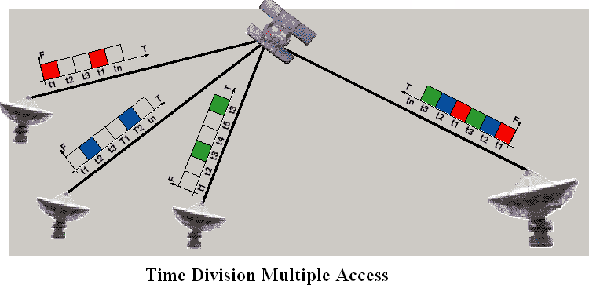

**Figure 4.1: Time Division Multiple Access**

TDMA systems still rely on switch to determine when to perform a handoff. Handoff occurs when a call is switched from one cell site to another while travelling. The TDMA handset constantly monitors the signals coming from other sites and reports it to the switch without caller’s awareness. The switch then uses this information for making better choices for handoff at appropriate times. TDMA handset performs hard handoff, i.e., whenever the user moves from one site to another, it breaks the connection and then provides a new connection with the new site.

**Advantages of TDMA:**

There are lots of advantages of TDMA in cellular technologies.

1. It can easily adapt to transmission of data as well as voice communication.
2. It has an ability to carry 64 kbps to 120 Mbps of data rates. This allows the operator to do services like fax, voice band data and SMS as well as bandwidth intensive application such as multimedia and video conferencing.
3. Since TDMA technology separates users according to time, it ensures that there will be no interference from simultaneous transmissions.
4. It provides users with an extended battery life, since it transmits only portion of the time during conversations. Since the cell size grows smaller, it proves to save base station equipment, space and maintenance.

TDMA is the most cost effective technology to convert an analog system to digital.

**Disadvantages of TDMA:**

One major disadvantage using TDMA technology is that the users has a predefined time slot. When moving from one cell site to other, if all the time slots in this cell are full the user might be disconnected. Likewise, if all the time slots in the cell in which the user is currently in are already occupied, the user will not receive a dial tone.

The second problem in TDMA is that it is subjected to multipath distortion. To overcome this distortion, a time limit can be used on the system. Once the time limit is expired, the signal is ignored.

**4.5 The concept of cellular network**

Mobile telephone networks are based on the concept of cells, circular zones that overlap to cover a geographical area.



**Figure 4.2: Celluar Network**

Cellular networks are based on the use of a central transmitter-receiver in each cell, called a "base station" (or Base Transceiver Station, written BTS). The smaller the radius of a cell, the higher is the available bandwidth. So, in highly populated urban areas, there are cells with a radius of a few hundred meters, while huge cells of up to 30 kilometers provide coverage in rural areas.

In a cellular network, each cell is surrounded by 6 neighboring cells (thus a cell is generally drawn as a hexagon). To avoid interference, adjacent cells cannot use the same frequency. In practice, two cells using the same frequency range must be separated by a distance of two to three times the diameter of the cell.

**4.6 Architecture of the GSM Network**

In a GSM network, the user terminal is called a mobile station. A mobile station is made up of a SIM (Subscriber Identity Module) card allowing the user to be uniquely identified and a mobile terminal.

The terminals (devices) are identified by a unique 15-digit identification number called IMEI (International Mobile Equipment Identity). Each SIM card also has a unique (and secret) identification number called IMSI (International Mobile Subscriber Identity). This code can be protected using a 4-digit key called a PIN code.

The SIM card therefore allows each user to be identified independently of the terminal used during communication with a base station. Communications occur through a radio link (air interface) between a mobile station and a base station.

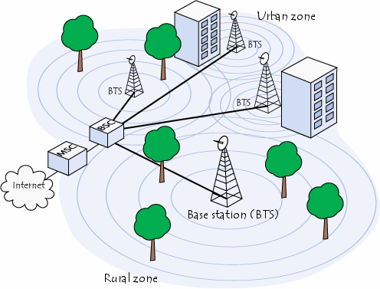

**Figure 4.3: Base Stations of Cellular Network**

All the base stations of a cellular network are connected to a base station controller (BSC) which is responsible for managing distribution of the resources. The system consisting of the base station controller and its connected base stations is called the Base Station Subsystem (BSS).

Finally, the base station controllers are themselves physically connected to the Mobile Switching (MSC), managed by the telephone network operator, which connects them to the public telephone network and the Internet. The MSC belongs to a Network Station Subsystem (NSS), which is responsible for managing user identities, their location and establishment of communications with other subscribers. The MSC is generally connected to databases that provide additional functions:

1. The Home Location Register (HLR) is a database containing information

(Geographic position, administrative information etc.) Of the subscribers registered in the area of the switch (MSC).

2. The Visitor Location Register (VLR) is a database containing information of users other than the local subscribers. The VLR retrieves the data of a new user from the HLR of the user's subscriber zone. The data is maintained as long as the user is in the zone and is deleted when the user leaves or after a long period of inactivity (terminal off).

1. The Equipment Identify Register (EIR) is a database listing the mobile terminals.
2. The Authentication (AUC) is responsible for verifying user identities.
3. The cellular network formed in this way is designed to support mobility via management of handovers (movements from one cell to another).

Finally, GSM networks support the concept of roaming i.e., movement from one operator network to another.

**Introduction to Modem:**

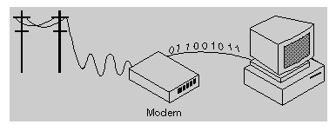

**Figure 4.4: Modem**

**Modem stands for modulator-demodulator.**

A modem is a device or program that enables a computer to transmit data over telephone or cable lines. Computer information is stored digitally, whereas information transmitted over telephone lines is transmitted in the form of analog waves. A modem converts between these two forms.

Fortunately, there is one standard interface for connecting external modems to computers called RS-232. Consequently, any external modem can be attached to any computer that has an RS-232 port, which almost all personal computers have. There are also modems that come as an expansion board that can be inserted into a vacant expansion slot. These are sometimes called onboard or internal modems.

While the modem interfaces are standardized, a number of different protocols for formatting data to be transmitted over telephone lines exist. Some, like CCITT V.34 are official standards, while others have been developed by private companies. Most modems have built-in support for the more common protocols at slow data transmission speeds at least, most modems can communicate with each other. At high transmission speeds, however, the protocols are less standardized.

Apart from the transmission protocols that they support, the following characteristics distinguish one modem from another:

* **Bps:** How fast the modem can transmit and receive data. At slow rates, modems are measured in terms of baud rates. The slowest rate is 300 baud (about 25 cps). At higher speeds, modems are measured in terms of bits per second (bps). The fastest modems run at 57,600 bps, although they can achieve even higher data transfer rates by compressing the data. Obviously, the faster the transmission rate, the faster the data can be sent and received. It should be noted that the data cannot be received at a faster rate than it is being sent.
* **Voice/data:** Many modems support a switch to change between voice and data modes. In data mode, the modem acts like a regular modem. In voice mode, the modem acts like a regular telephone. Modems that support a voice/data switch have a built-in loudspeaker and microphone for voice communication.

* **Auto-answer:** An auto-answer modem enables the computer to receive calls in the absence of the operator.

* **Data compression**: Some modems perform data compression, which enables them to send data at faster rates. However, the modem at the receiving end must be able to decompress the data using the same compression technique.

* **Flash memory:** Some modems come with flash memory rather than conventional ROM which means that the communications protocols can be easily updated if necessary.

* **Fax capability:** Most modern modems are fax modems, which mean that they can send and receive faxes.

**GSM Modem**: A GSM modem is a wireless modem that works with a GSM wireless network. A wireless modem behaves like a dial-up modem. The main difference between them is that a dial-up modem sends and receives data through a fixed telephone line while a wireless modem sends and receives data through radio waves.

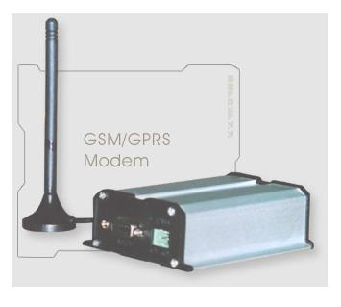

**Figure 4.5: GSM Modem**

A GSM modem can be an external device or a PC Card / PCMCIA Card. Typically, an external GSM modem is connected to a computer through a serial cable or a USB cable. A GSM modem in the form of a PC Card / PCMCIA Card is designed for use with a laptop computer. It should be inserted into one of the PC Card / PCMCIA Card slots of a laptop computer. Like a GSM mobile phone, a GSM modem requires a SIM card from a wireless carrier in order to operate.

A SIM card contains the following information:

* Subscriber telephone number (MSISDN)
* International subscriber number (IMSI, International Mobile Subscriber Identity)
* State of the SIM card
* Service code (operator)
* Authentication key
* PIN (Personal Identification Code)
* PUK (Personal Unlock Code)

Computers use AT commands to control modems. Both GSM modems and dial-up modems support a common set of standard AT commands. In addition to the standard AT commands, GSM modems support an extended set of AT commands. These extended AT commands are defined in the GSM standards.

With the extended AT commands, the following operations can be performed:

* Reading, writing and deleting SMS messages.
* Sending SMS messages.
* Monitoring the signal strength.
* Monitoring the charging status and charge level of the battery.
* Reading, writing and searching phone book entries.

The number of SMS messages that can be processed by a GSM modem per minute is very low i.e., about 6 to 10 SMS messages per minute.

**Introduction to AT Commands**

AT commands are instructions used to control a modem. AT is the abbreviation of ATTENTION. Every command line starts with "AT" or "at".

That's the reason modem commands are called AT commands. Many of the commands that are used to control wired dial-up modems, such as ATD (Dial), ATA (Answer), ATH (Hook control) and ATO (Return to online data state) are also supported by GSM modems and mobile phones.

Besides this common AT command set, GSM modems and mobile phones support an AT command set that is specific to the GSM technology, which includes SMS-related commands like AT+CMGS (Send SMS message), AT+CMSS (Send SMS message from storage), AT+CMGL (List SMS messages) and AT+CMGR (Read SMS messages).

It should be noted that the starting "AT" is the prefix that informs the modem about the start of a command line. It is not part of the AT command name. For example, D is the actual AT command name in ATD and +CMGS is the actual AT command name in AT+CMGS.

Some of the tasks that can be done using AT commands with a GSM modem or mobile phone are listed below:

* Get basic information about the mobile phone or GSM modem. For example, name of manufacturer (AT+CGMI), model number (AT+CGMM), IMEI number (International Mobile Equipment Identity) (AT+CGSN) and software version (AT+CGMR).
* Get basic information about the subscriber. For example, MSISDN (AT+CNUM) and IMSI number (International Mobile Subscriber Identity) (AT+CIMI).
* Get the current status of the mobile phone or GSM/GPRS modem. For example, mobile phone activity status (AT+CPAS), mobile network registration status (AT+CREG), radio signal strength (AT+CSQ), battery charge level and battery charging status (AT+CBC).
* Establish a data connection or voice connection to a remote modem (ATD, ATA, etc).
* Send and receive fax (ATD, ATA, AT+F*).
* Send (AT+CMGS, AT+CMSS), read (AT+CMGR, AT+CMGL), write (AT+CMGW) or delete (AT+CMGD) SMS messages and obtain notifications of newly received SMS messages (AT+CNMI).
* Read (AT+CPBR), write (AT+CPBW) or search (AT+CPBF) phonebook entries.
* Perform security-related tasks, such as opening or closing facility locks (AT+CLCK), checking whether a facility is locked (AT+CLCK) and changing passwords (AT+CPWD). (Facility lock examples: SIM lock [a password must be given to the SIM card every time the mobile phone is switched on] and PH-SIM lock [a certain SIM card is associated with the mobile phone. To use other SIM cards with the mobile phone, a password must be entered.])
* Control the presentation of result codes / error messages of AT commands. For example, the user can control whether to enable certain error messages (AT+CMEE) and whether error messages should be displayed in numeric format or verbose format (AT+CMEE=1 or AT+CMEE=2).
* Get or change the configurations of the mobile phone or GSM/GPRS modem. For example, change the GSM network (AT+COPS), bearer service type (AT+CBST), radio link protocol parameters (AT+CRLP), SMS centre address (AT+CSCA) and storage of SMS messages (AT+CPMS).
* Save and restore configurations of the mobile phone or GSM/GPRS modem. For example, save (AT+CSAS) and restore (AT+CRES) settings related to SMS messaging such as the SMS centre address.

It should be noted that the mobile phone manufacturers usually do not implement all AT commands, command parameters and parameter values in their mobile phones. Also, the behaviour of the implemented AT commands may be different from that defined in the standard. In general, GSM modems, designed for wireless applications, have better support of AT commands than ordinary mobile phones.

**4.7 Basic concepts of SMS technology**

1. Validity Period of an SMS Message

An SMS message is stored temporarily in the SMS centre if the recipient mobile phone is offline. It is possible to specify the period after which the SMS message will be deleted from the SMS centre so that the SMS message will not be forwarded to the recipient mobile phone when it becomes online. This period is called the validity period.

A mobile phone should have a menu option that can be used to set the validity period. After setting it, the mobile phone will include the validity period in the outbound SMS messages automatically.

1. Message Status Reports

Sometimes the user may want to know whether an SMS message has reached the recipient mobile phone successfully. To get this information, you need to set a flag in the SMS message to notify the SMS centre that a status report is required about the delivery of this SMS message. The status report is sent to the user mobile in the form of an SMS message.

A mobile phone should have a menu option that can be used to set whether the status report feature is on or off. After setting it, the mobile phone will set the corresponding flag in the outbound SMS messages for you automatically. The status report feature is turned off by default on most mobile phones and GSM modems.

1. Message Submission Reports

After leaving the mobile phone, an SMS message goes to the SMS centre. When it reaches the SMS, the SMS centre will send back a message submission report to the mobile phone to inform whether there are any errors or failures (e.g. incorrect SMS message format, busy SMS centre, etc). If there is no error or failure, the SMS centre sends back a positive submission report to the mobile phone. Otherwise it sends back a negative submission report to the mobile phone. The mobile phone may then notify the user that the message submission was failed and what caused the failure.

If the mobile phone does not receive the message submission report after a period of time, it concludes that the message submission report has been lost. The mobile phone may then send the SMS message again to the SMS centre. A flag will be set in the new SMS message to inform the SMS centre that this SMS message has been sent before. If the previous message submission was successful, the SMS centre will ignore the new SMS message but send back a message submission report to the mobile phone. This mechanism prevents the sending of the same SMS message to the recipient multiple times.

Sometimes the message submission report mechanism is not used and the acknowledgement of message submission is done in a lower layer.

1. Message Delivery Reports

After receiving an SMS message, the recipient mobile phone will send back a message delivery report to the SMS centre to inform whether there are any errors or failures (example causes: unsupported SMS message format, not enough storage space, etc). This process is transparent to the mobile user. If there is no error or failure, the recipient mobile phone sends back a positive delivery report to the SMS centre. Otherwise it sends back a negative delivery report to the SMS centre.

If the sender requested a status report earlier, the SMS centre sends a status report to the sender when it receives the message delivery report from the recipient. If the SMS centre does not receive the message delivery report after a period of time, it concludes that the message delivery report has been lost. The SMS centre then sends the SMS message to the recipient for the second time. Sometimes the message delivery report mechanism is not used and the acknowledgement of message delivery is done in a lower layer.

**CHAPTER-5**

**GPS TECHNOLOGY**

Global Positioning System (GPS) technology is a great boon to anyone who has the need to navigate either great or small distances. This wonderful navigation technology was actually first available for government use back in the late 1970s. In the past ten or so years, It has been made available to the general public in the form of handheld receivers that use this satellite technology provided by the U.S. government.

Through the use of these handheld receivers, one can navigate back to a starting point or other predetermined locations without the use of maps or any other equipment. In conjunction with accurate maps like ones provided by the USGS, and other basic tools like a compass and Lat/Long or UTM scales, one can navigate to identified locations on maps or take readings from a location that they are at or have been at and plot those locations on a map.

All of these features make it a very desirable and useful technology for a mired of activities including Search and Rescue, Aviation and Nautical navigation, hiking, hunting, camping, fishing, and many more. All of these various GPS users have unique needs which require different levels of understanding and skill in using this technology.

The Global Positioning System (GPS) includes 24 satellites, in circular orbits around Earth with orbital period of 12 hours, distributed in six orbital planes equally spaced in angle. Each satellite carries an operating atomic clock (along with several backup clocks) and emits timed signals that include a code telling its location. By analyzing signals from at least four of these satellites, a receiver on the surface of Earth with a built-in microprocessor can display the location of the receiver (latitude, longitude, and altitude). Consumers receivers are the approximate size of a hand-held calculator, cost a few hundred dollars, and provide a position accurate to 100 meters or so. Military versions decode the signal to provide position readings that are more accurate—the exact accuracy a military secret. GPS satellites are gradually revolutionizing driving, flying, hiking, exploring, rescuing, and map making.

Airports use one GPS receiver at the control tower and one on the approaching airplane. The two receivers are close together, which cancels errors due to propagation of signals between each receiver and overhead satellites. It also cancels the “jitter” intentionally introduced into the satellite signal to make civilian receivers less accurate than military receivers.

The goal of the Global Positioning System (GPS) is to determine your position on Earth in three dimensions: east-west, north-south, and vertical (longitude, latitude, and altitude). Signals from three overhead satellites provide this information. Each satellite sends a signal that codes where the satellite is and the time of emission of the signal. The receiver clock times the reception of each signal, then subtracts the emission time to determine the time lapse and hence how far the signal has travelled (at the speed of light).

This is the distance the satellite was from you when it emitted the signal. In effect, three spheres are constructed from these distances, one sphere centered on each satellite. You are located at the single point at which the three spheres intersect.

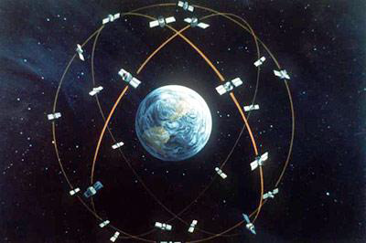

**Figure 5.1: Artist’s concept of the GPS satellite constellation**

**5.1 Operating Principles:**

The basis of the GPS technology is a set of 24 satellites that are continuously orbiting the earth. These satellites are equipped with atomic clocks and send out radio signals as to the exact time and their location. These radio signals from the satellites are picked up by the GPS receiver. Once the GPS receiver locks on to four or more of these satellites, it can triangulate its location from the known positions of the satellites.

Regarding the issue of time, UTC time is the basis of all GPS time functions and calculations. If nothing else, in owning a GPS receiver, you have in your possession the most accurate time piece available. Your receiver updates itself from the atomic clocks on the satellites. It is also very important for you to understand that your receiver must know the time difference between your location and of Greenwich England or UTC time. This is a function in the set- up of all GPS receivers. With many GPS manufacturers, this is referred to as Offset which is referring to the offset or difference in time zones from the present location to UTC time.

The functionality of a receiver is dependent on the ability to receive signals from the satellites. Certain locations such as under very thick foliage or down in the bottom of a slot canyon will preclude your receiver from getting a good signal from enough satellites to determine your location. With many of the newer receivers however, these problems are minimal. All receivers have warning messages when they are not getting sufficient signal to properly navigate.

**Accuracy:**

The accuracy of the receivers is dependent on the number and quality of the signals it is getting from the satellites and from a factor called Selected Availability.

Selected Availability is an intentional error that is introduced into the signals coming from the Satellites that create readings that can be off as much as 300 feet. Even so, the accuracy levels with Selected Availability turned on, is usually within 100 ft. or better.

Other factors affect accuracy such, quality of GPS signals from the satellites, and operator error. Operator error can include such things as inputting the wrong values for position coordinates and as using the wrong datum for the map being referenced. These issues will be covered in Chapter two.

**5.2 GPS Receiver Set-Up:**

To be able to properly use a GPS receiver, it needs to be set-up and initialized. Set-up establishes the basic information about the units of distance, speed, Map Datum, Navigation Grid system, time difference from Greenwich England or UTC time, and other basics.

The user’s manual that comes with each GPS receiver gives detailed instructions on the process of selecting the options for initialization and set-up. This must be done to be able to use the unit for navigation.

**Most Common Set-up Components:**

1. **Initialization**

Initialization is the process of telling the receiver your approximate location on the surface of the earth. This must be done the first time you use the receiver or if it has moved more than 300 miles from the last location where it was being used. Otherwise, it will take an unreasonable amount of time for the receiver to establish what is called a Position Fix.

**2. Units, for speed, distance etc.**

Self explanatory, units of feet, meters, miles.

**3. Grid System**

Latitude & Longitude or UTM can be selected. Lat./Long usually has choices of Degrees, Minutes, & seconds or Degrees, Minutes, and ,oo Minutes (instead of seconds).

**4. Datum**

This references the map that coordinates will be plotted on or taken from.

**5. North reference**

Either Magnetic North (same as compass) or True North.

**6. Time Offset. From UTC**

Time zone difference from Greenwich England.

Once the set-up has been completed and the unit has been initialized, it will then locks on the signals of three or more satellites and establish a Position Fix. The Position Fix is the calculated position of the receiver’s current location.

**GPS is a Satellite Navigation System**

* GPS is funded by and controlled by the U. S. Department of Defense (DOD). While there are many thousands of civil users of GPS world- wide, the system was designed for and is operated by the U. S. military.
* GPS provides specially coded satellite signals that can be processed in a GPS receiver, enabling the receiver to compute position, velocity and time.
* Four GPS satellite signals are used to compute positions in three dimensions and the time offset in the receiver clock.

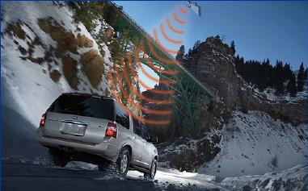

**Figure 5.2: Space Vehicles send radio signals from space**

**5.3 Space Segment**

* The Space Segment of the system consists of the GPS satellites. These space vehicles (SVs) send radio signals from space.

The nominal GPS Operational Constellation consists of 24 satellites that orbit the earth in 12 hours. There are often more than 24 operational satellites as new ones are launched to replace older satellites. The satellite orbits repeat almost the same ground track (as the earth turns beneath them) once each day. The orbit altitude is such that the satellites repeat the same track and configuration over any point approximately each 24 hours (4 minutes earlier each day). There are six orbital planes (with nominally four SVs in each), equally spaced (60 degrees apart), and inclined at about fifty-five degrees with respect to the equatorial plane. This constellation provides the user with between five and eight SVs visible from any point on the earth.

**Control Segment**

* The Control Segment consists of a system of tracking stations located around the world.

The Master Control facility is located at Schriever Air Force Base (formerly Falcon AFB) in Colorado. These monitor stations measure signals from the SVs which are incorporated into orbital models for each satellites. The models compute precise orbital data (ephemeris) and SV clock corrections for each satellite. The Master Control station uploads ephemeris and clock data to the SVs. The SVs then send subsets of the orbital ephemeris data to GPS receivers over radio signals.

**User Segment**

* The GPS User Segment consists of the GPS receivers and the user community. GPS receivers convert SV signals into position, velocity, and time estimates. Four satellites are required to compute the four dimensions of X, Y, Z (position) and Time. GPS receivers are used for navigation, positioning, time dissemination, and other research.
* Navigation in three dimensions is the primary function of GPS. Navigation receivers are made for aircraft, ships, ground vehicles, and for hand carrying by individuals.

* Precise positioning is possible using GPS receivers at reference locations providing corrections and relative positioning data for remote receivers. Surveying, geodetic control, and plate tectonic studies are examples.

* Time and frequency dissemination, based on the precise clocks on board the SVs and controlled by the monitor stations, is another use for GPS. Astronomical observatories, telecommunications facilities, and laboratory standards can be set to precise time signals or controlled to accurate frequencies by special purpose GPS receivers.

* Research projects have used GPS signals to measure atmospheric parameters.

**5.4 Factors that affect GPS**

There are a number of potential error sources that affect either the GPS signal directly or your ability to produce optimal results:

* Number of satellites-minimum number required:

You must track at least four common satellites - the same four satellites - at both the reference receiver and rover for either DGPS or RTK solutions. Also to achieve centimeter -level accuracy, remember you must have a fifth satellite for on-the fly RTK initialization. This extra satellite adds a check on the internal calculation. Any additional satellites beyond five provide even more checks, which is always useful.

* Multipath-reflection of GPS signals near the antenna:

Multipath is simply reflection of signals similar to the phenomenon of ghosting on our television screen. GPS signals may be reflected by surfaces near the antennae, causing error in the travel time and therefore error in the GPS positions.

* Ionosphere - change in the travel time of the signal:

Before GPS signals reach your antenna on the earth, they pass through a zone of charged particles called the ionosphere, which changes the speed of the signal. If your reference and rover receivers are relatively close together, the effect of ionosphere tends to be minimal. And if you are working with the lower range of GPS precisions, the ionosphere is not a major consideration. However if your rover is working too far from the reference station, you may experience problems, particularly with initializing your RTK fixed solution.

* Troposphere - change in the travel time of the signal:

Troposphere is essentially the weather zone of our atmosphere, and droplets of water vapour in it can affect the speed of the signals. The vertical component of your GPS answer (your elevation) is particularly sensitive to the troposphere.

* Satellite Geometry - general distribution of the satellites:

Satellite Geometry - or the distribution of satellites in the sky - effects the computation of your position. This is often referred to as Position Dilution of Precision (PDOP).

PDOP is expressed as a number, where lower numbers are preferable to higher numbers. The best results are obtained when PDOP is less than about 7. PDOP is determined by your geographic location, the time of day you are working, and any site obstruction, which might block satellites. You can use planning software to help you determine when you'll have the most satellites in a particular area. When satellites are spread out, PDOP is Low (good). When satellites are closer together, PDOP is High (weak).

* Satellite Health - Availability of Signal:

While the satellite system is robust and dependable, it is possible for the satellites to occasionally be unhealthy. A satellite broadcasts its health status, based on information from the U.S. Department of Defense. Your receivers have safeguards to protect against using data from unhealthy satellites

* Signal Strength - Quality of Signal :

The strength of the satellite signal depends on obstructions and the elevation of the satellites above the horizon. To the extent it is possible, obstructions between your GPS antennae and the sky should be avoided. Also watch out for satellites which are close to the horizon, because the signals are weaker.

* Distance from the Reference Receiver :

The effective range of a rover from a reference station depends primarily on the type of accuracy you are trying to achieve. For the highest real time accuracy (RTK fixed), rovers should be within about 10-15 Km (about 6-9 miles) of the reference station. As the range exceeds this recommended limit, you may fail to initialize and be restricted to RTK float solutions (decimeter accuracy).

* Radio Frequency (RF) Interference:

RF interference may sometimes be a problem both for your GPS reception and the radio system. Some sources of RF interference include:

o Radio towers

o Transmitters

o Satellite dishes

o Generators

One should be particularly careful of sources which transmit either near the GPS frequencies (1227 and 1575 MHz) or near harmonics (multiples) of these frequencies. One should also be aware of the RF generated by his own machines.

* Loss of Radio Transmission from Base:

If, for any reason, there is an interruption in the radio link between a reference receiver and a rover, then your rover is left with an autonomous position. It is very important to set up a network of radios and repeaters, which can provide the uninterrupted radio link needed for the best GPS results.

**5.5 GPS Receiver:**

When people talk about "a GPS," they usually mean a GPS receiver. The Global Positioning System (GPS) is actually a constellation of 27 Earth- orbiting satellites (24 in operation and three extras in case one fails).

A GPS receiver's job is to locate four or more of these satellites, figure out the distance to each, and use this information to deduce its own location. This operation is based on a simple mathematical principle called trilateration. Trilateration in three-dimensional space can be a little tricky.

**3-D Trilateration**

If you know you are 10 miles from satellite A in the sky, you could be anywhere on the surface of a huge, imaginary sphere with a 10-mile radius. If you also know you are 15 miles from satellite B, you can overlap the first sphere with another, larger sphere. The spheres intersect in a perfect circle. If you know the distance to a third satellite, you get a third sphere, which intersects with this circle at two points.

The Earth itself can act as a fourth sphere -- only one of the two possible points will actually be on the surface of the planet, so you can eliminate the one in space. Receivers generally look to four or more satellites, however, to improve accuracy and provide precise altitude information.

In order to make this simple calculation, then, the GPS receiver has to know two things:

* The location of at least three satellites above you
* The distance between you and each of those satellites

The GPS receiver figures both of these things out by analyzing high- frequency, low-power radio signals from the GPS satellites. Better units have multiple receivers, so they can pick up signals from several satellites simultaneously.

Radio waves are electromagnetic energy, which means they travel at the speed of light (about 186,000 miles per second, 300,000 km per second in a vacuum). The receiver can figure out how far the signal has traveled by timing how long it took the signal to arrive.

**5.6 GPS Calculations**

At a particular time (let's say midnight), the satellite begins transmitting a long, digital pattern called a pseudo-random code. The receiver begins running the same digital pattern also exactly at midnight. When the satellite's signal reaches the receiver, its transmission of the pattern will lag a bit behind the receiver's playing of the pattern.

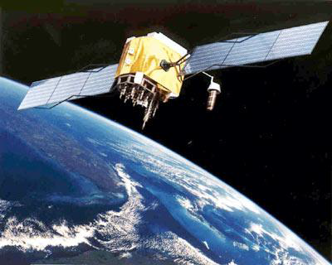

**Figure 5.3: A GPS Satellite**

The length of the delay is equal to the signal's travel time. The receiver multiplies this time by the speed of light to determine how far the signal travelled. Assuming the signal travelled in a straight line, this is the distance from receiver to satellite.

In order to make this measurement, the receiver and satellite both need clocks that can be synchronized down to the nanosecond. To make a satellite positioning system using only synchronized clocks, you would need to have atomic clocks not only on all the satellites, but also in the receiver itself. But atomic clocks cost somewhere between $50,000 and $100,000, which makes them a just a bit too expensive for everyday consumer use.

The Global Positioning System has a clever, effective solution to this problem. Every satellite contains an expensive atomic clock, but the receiver itself uses an ordinary quartz clock, which it constantly resets. In a nutshell, the receiver looks at incoming signals from four or more satellites and gauges its own inaccuracy. In other words, there is only one value for the "current time" that the receiver can use. The correct time value will cause all of the signals that the receiver is receiving to align at a single point in space. That time value is the time value held by the atomic clocks in all of the satellites. So the receiver sets its clock to that time value, and it then has the same time value that all the atomic clocks in all of the satellites have. The GPS receiver gets atomic clock accuracy "for free."

When you measure the distance to four located satellites, you can draw four spheres that all intersect at one point. Three spheres will intersect even if your numbers are way off, but four spheres will not intersect at one point if you've measured incorrectly. Since the receiver makes all its distance measurements using its own built-in clock, the distances will all be proportionally incorrect.

The receiver can easily calculate the necessary adjustment that will cause the four spheres to intersect at one point. Based on this, it resets its clock to be in sync with the satellite's atomic clock. The receiver does this constantly whenever it's on, which means it is nearly as accurate as the expensive atomic clocks in the satellites.

In order for the distance information to be of any use, the receiver also has to know where the satellites actually are. This isn't particularly difficult because the satellites travel in very high and predictable orbits. The GPS receiver simply stores an almanac that tells it where every satellite should be at any given time. Things like the pull of the moon and the sun do change the satellites' orbits very slightly, but the Department of Defence constantly monitors their exact positions and transmits any adjustments to all GPS receivers as part of the satellites' signals.

**Differential GPS**

So far, we've learned how a GPS receiver calculates its position on earth based on the information it receives from four located satellites. This system works pretty well, but inaccuracies do pop up. For one thing, this method assumes the radio signals will make their way through the atmosphere at a consistent speed (the speed of light). In fact, the Earth's atmosphere slows the electromagnetic energy down somewhat, particularly as it goes through the ionosphere and troposphere. The delay varies depending on where you are on Earth, which means it's difficult to accurately factor this into the distance calculations. Problems can also occur when radio signals bounce off large objects, such as skyscrapers, giving a receiver the impression that a satellite is farther away than it actually is. On top of all that, satellites sometimes just send out bad almanac data, misreporting their own position.

**Differential GPS (DGPS)** helps correct these errors. The basic idea is to gauge GPS inaccuracy at a stationary receiver station with a known location. Since the DGPS hardware at the station already knows its own position, it can easily calculate its receiver's inaccuracy. The station then broadcasts a radio signal to all DGPS-equipped receivers in the area, providing signal correction information for that area. In general, access to this correction information makes DGPS receivers much more accurate than ordinary receivers.

The most essential function of a GPS receiver is to pick up the transmissions of at least four satellites and combine the information in those transmissions with information in an electronic almanac, all in order to figure out the receiver's position on Earth.

Once the receiver makes this calculation, it can tell you the latitude, longitude and altitude (or some similar measurement) of its current position. To make the navigation more user-friendly, most receivers plug this raw data into map files stored in memory.

A standard GPS receiver will not only place you on a map at any particular location, but will also trace your path across a map as you move. If you leave your receiver on, it can stay in constant communication with GPS satellites to see how your location is changing. With this information and its built-in clock, the receiver can give you several pieces of valuable information:

1. How far you've travelled (odometer)
2. How long you've been travelling
3. Your current speed (speedometer)
4. Your average speed
5. A "bread crumb" trail showing you exactly where you have travelled on the map
6. The estimated time of arrival at your destination if you maintain your current speed.

**5.7 GPS Applications**

One of the most significant and unique features of the Global Positioning Systems is the fact that the positioning signal is available to users in any position worldwide at any time. With a fully operational GPS system, it can be generated to a large community of likely to grow as there are multiple applications, ranging from surveying, mapping, and navigation to GIS data capture. The GPS will soon be a part of the overall utility of technology. There are countless GPS applications, a few important ones are covered in the following passage.

**Surveying and Mapping**

The high precision of GPS carrier phase measurements, together with appropriate adjustment algorithms, provides an adequate tool for a variety of tasks for surveying and mapping. Using DGPs methods, accurate and timely mapping of almost anything can be carried out. The GPS is used to map cut blocks, road alignments, and environmental hazards such as landslides, forest fires, and oil spills. Applications, such as cadastral mapping, needing a high degree of accuracy also can be carried out using high grade GPS receivers. Continuous kinematic techniques can be used for topographic surveys and accurate linear mapping.

**Navigation**

Navigation using GPS can save countless hours in the field. Any feature, even if it is under water, can be located up to one hundred meters simply by scaling coordinates from a map, entering waypoints, and going directly to the site. Examples include road intersections, corner posts, plot canters, accident sites, geological formations, and so on. GPS navigation in helicopters, in vehicles, or in a ship can provide an easy means of navigation with substantial savings.

**Remote Sensing and GIS**

It is also possible to integrate GPS positioning into remote-sensing methods such as photogrammetric and aerial scanning, magnetometers and video technology. Using DGPS or kinematic techniques, depending upon the accuracy required, real time or post-processing will provide positions for the sensor which can be projected to the ground, instead of having ground control projected to an image. GPS are becoming very effective tools for GIS data capture. The GIS user community benefits from the use of GPS for location data capture in various GIS applications. The GPS can easily be linked to a laptop computer in the field, and, with appropriate software, users can also have all their data on a common base with every little distortion. Thus GPS can help in several aspects of construction of accurate and timely GIS databases.

**Geodesy**

Geodetic mapping and other control surveys can be carried out effectively using high-grade GPS equipment. Especially when helicopters were used or when the line of sight is not possible, GPS can set new standards of accuracy and productivity.

**Military**

The GPS was primarily developed for real time military positioning. Military applications include airborne, marine, and land navigation.

**Future of GPS Technology**

Barring significant new complications due to S/A (Selective Availability) from DOD, the GPS industry is likely to continue to develop in the civilian community. There are currently more than 50 manufacturers of GPs receivers, with the trend continuing to be towards smaller, less expensive, and more easily operated devices. While highly accurate, portable (hand-held) receivers are already available, current speculation envisions inexpensive and equally accurate 'wristwatch locators' and navigational guidance systems for automobiles. However, there is one future trend that will be very relevant to the GIS user community, namely, community base stations and regional receive networks, as GPS management and technological innovations that will make GPS surveying easier and more accurate.

**CHAPTER-6**

**SOFTWARE IMPLEMENTATION**

**SOFTWARE USED:**

* Keil software for c programming

**6.1. KEIL SOFTWARE:**

It is possible to create the source files in a text editor such as Notepad, run the Compiler on each C source file, specifying a list of controls, run the Assembler on each Assembler source file, specifying another list of controls, run either the Library Manager or Linker (again specifying a list of controls) and finally running the Object-HEX Converter to convert the Linker output file to an Intel Hex File. Once that has been completed the Hex File can be downloaded to the target hardware and debugged. Alternatively KEIL can be used to create source files; automatically compile, link and covert using options set with an easy to use user interface and finally simulate or perform debugging on the hardware with access to C variables and memory. Unless you have to use the tolls on the command line, the choice is clear. KEIL Greatly simplifies the process of creating and testing an embedded application.

**6.2. PROJECTS:**

The user of KEIL centers on “projects”. A project is a list of all the source files required to build a single application, all the tool options which specify exactly how to build the application, and – if required – how the application should be simulated. A project contains enough information to take a set of source files and generate exactly the binary code required for the application. Because of the high degree of flexibility required from the tools, there are many options that can be set to configure the tools to operate in a specific manner. It would be tedious to have to set these options up every time the application is being built; therefore they are stored in a project file. Loading the project file into KEIL informs KEIL which source files are required, where they are, and how to configure the tools in the correct way. KEIL can then execute each tool with the correct options. It is also possible to create new projects in KEIL. Source files are added to the project and the tool options are set as required. The project can then be saved to preserve the settings. The project is reloaded and the simulator or debugger started, all the desired windows are opened. KEIL project files have the extension

**6.3. SIMULATOR/DEBUGGER:**

The simulator/ debugger in KEIL can perform a very detailed simulation of a micro controller along with external signals. It is possible to view the precise execution time of a single assembly instruction, or a single line of C code, all the way up to the entire application, simply by entering the crystal frequency. A window can be opened for each peripheral on the device, showing the state of the peripheral. This enables quick trouble shooting of mis-configured peripherals. Breakpoints may be set on either assembly instructions or lines of C code, and execution may be stepped through one instruction or C line at a time. The contents of all the memory areas may be viewed along with ability to find specific variables. In addition the registers may be viewed allowing a detailed view of what the microcontroller is doing at any point in time.

**6.4. ARM SOFTWARE:**

**About Keil ARM:**

1. Click on the Keil u Vision3 Icon on Desktop

2. The following fig will appear

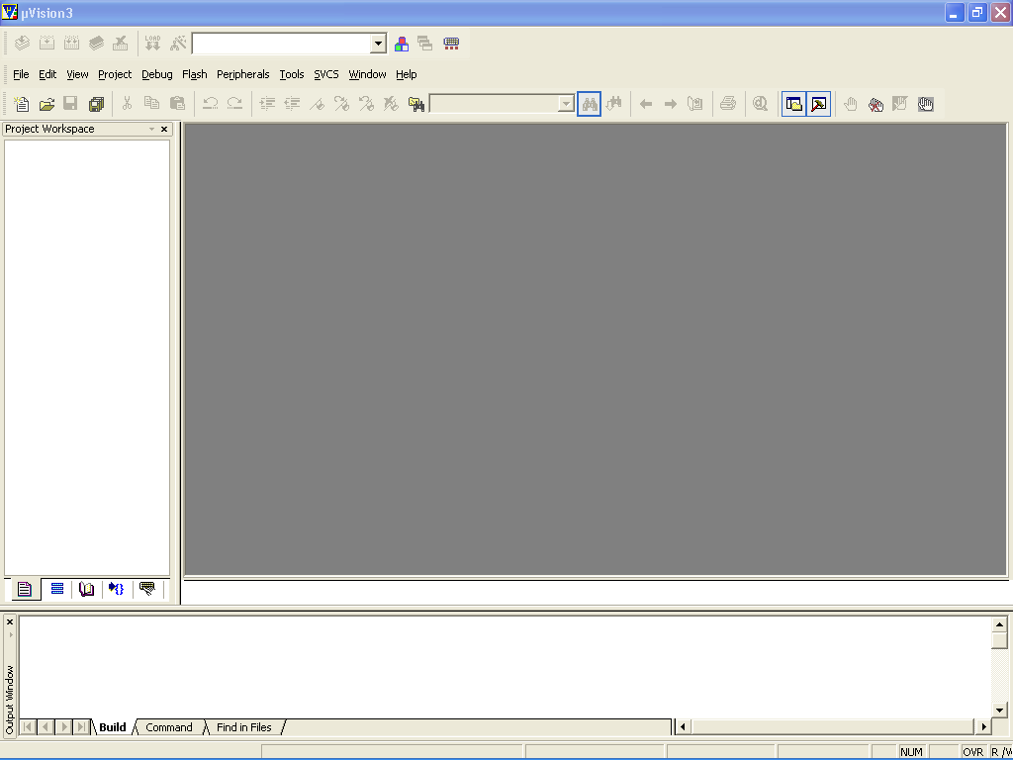

3. Click on the Project menu from the title bar

4. Then Click on New Project

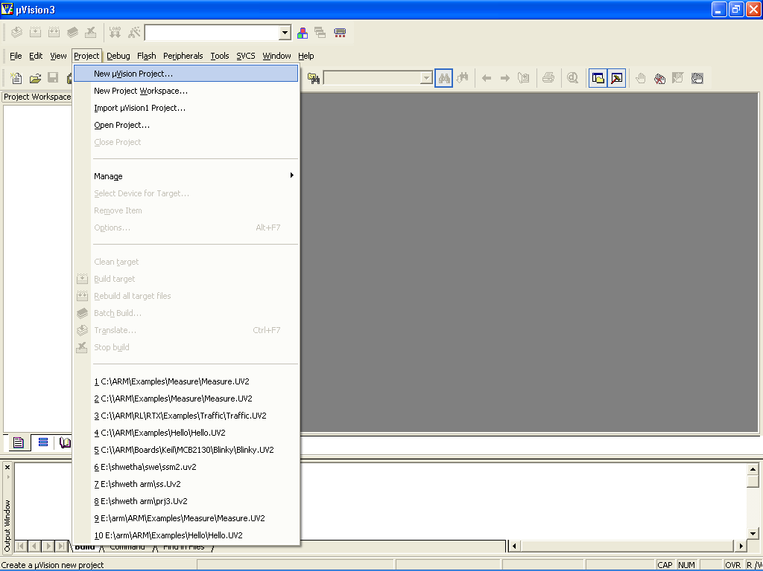

5. SaProject by typive the ng suitable project name with no extension in u r own folder sited in either C:\ or D:\ 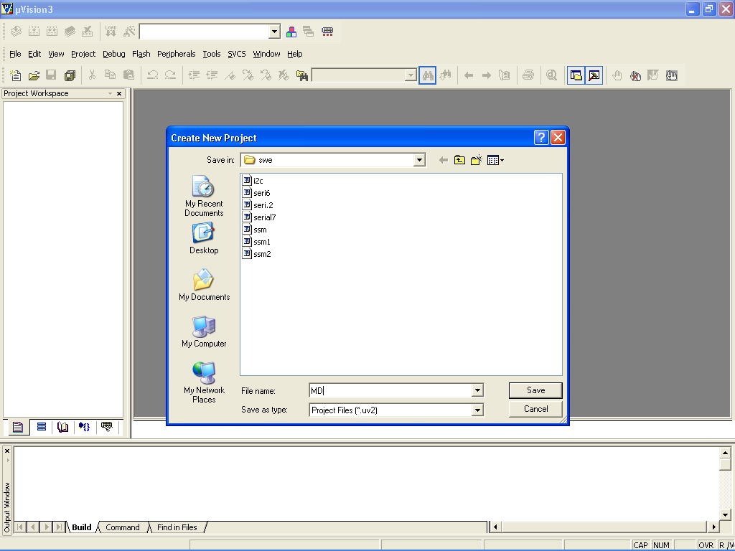

6. Then Click on save button above.

7. Select the component for u r project. i.e. ATMEL

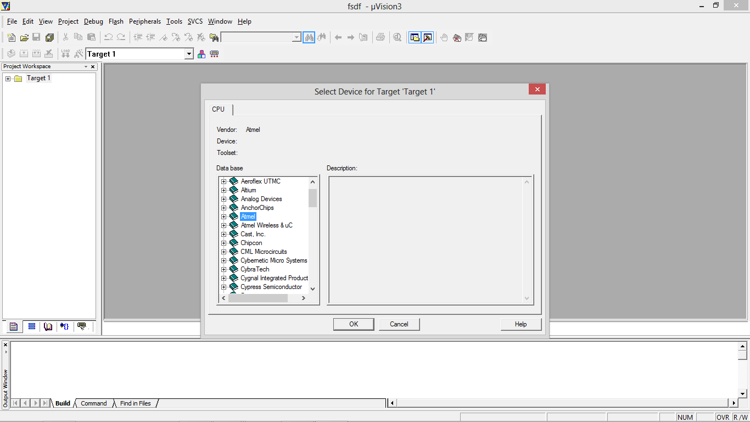

8. Select AT89C51 as shown below

9. Then Click on “OK”

10. The Following fig will appear

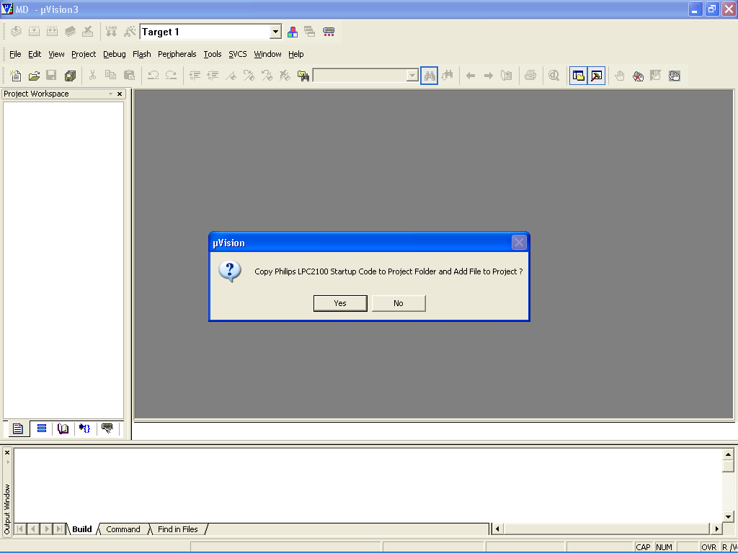

11. Then Click YES

12. Now your project is ready to USE

13. Now double click on the Target1, you would get another option “Source group 1” as shown in next page.

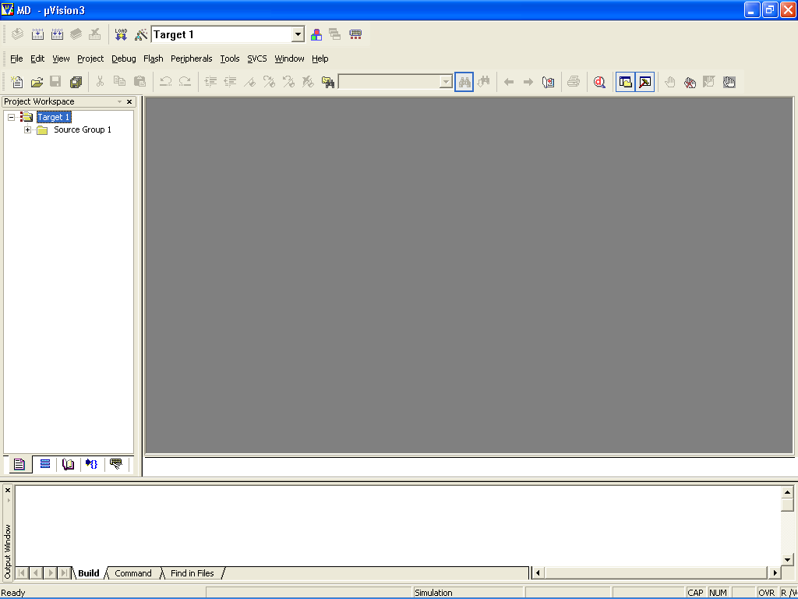

1. Click on the file option from menu bar and select “new”

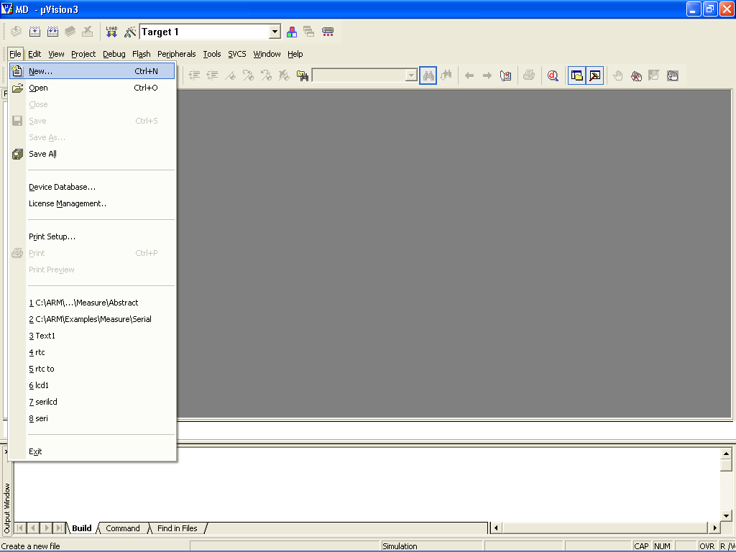

15. The next screen will be as shown in next page, and just maximize it by double clicking on its blue boarder.

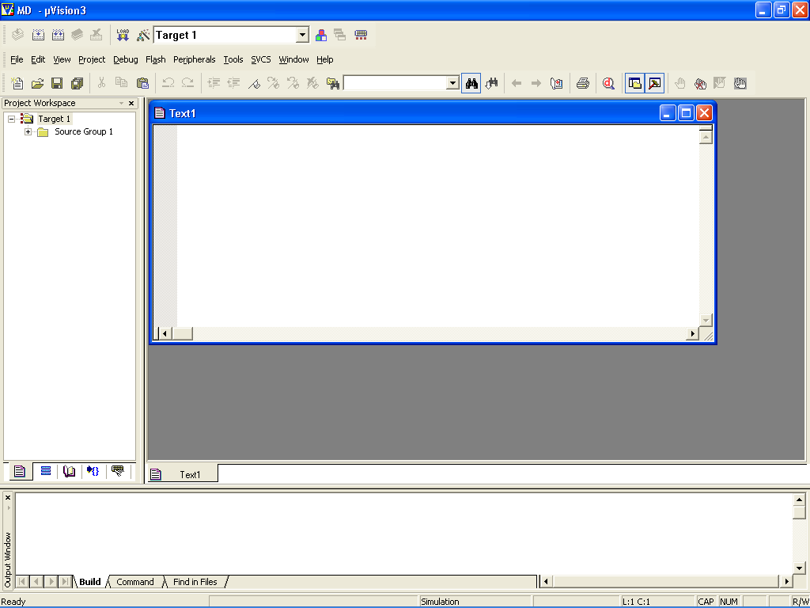

16. Now start writing program in either in “C” or “ASM”

17. For a program written in Assembly, then save it with extension “. Asm” and for “C” based program save it with extension“.C”. 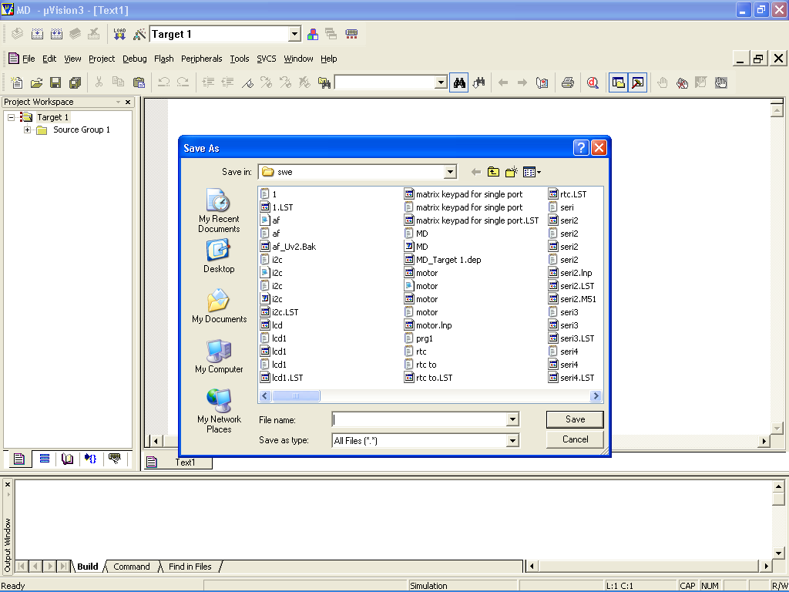

18. Now right click on Source group 1 and click on “**Add files to Group Source**”.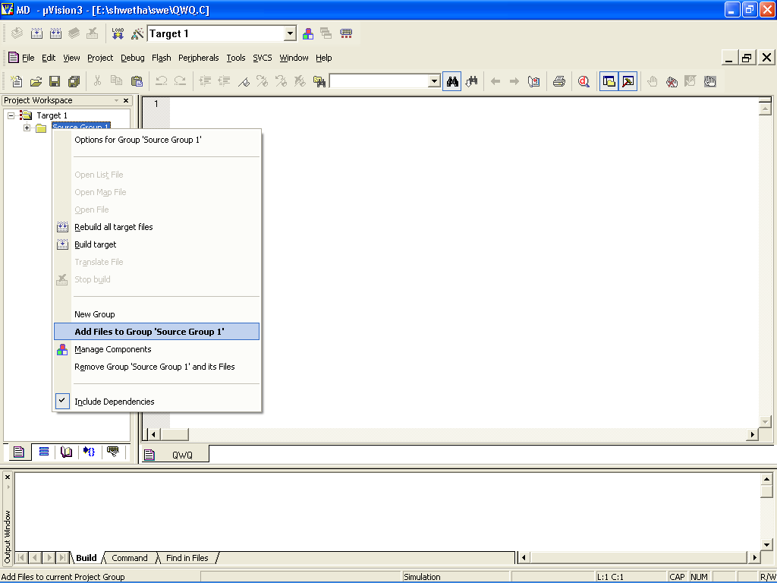

19. Now you will get another window, on which by default “C” files will appear.

20. Now select as per your file extension given while saving the file.

21. Click only one time on option “**ADD**”.

22. Now Press function key F7 to compile. Any error will appear if so happen. 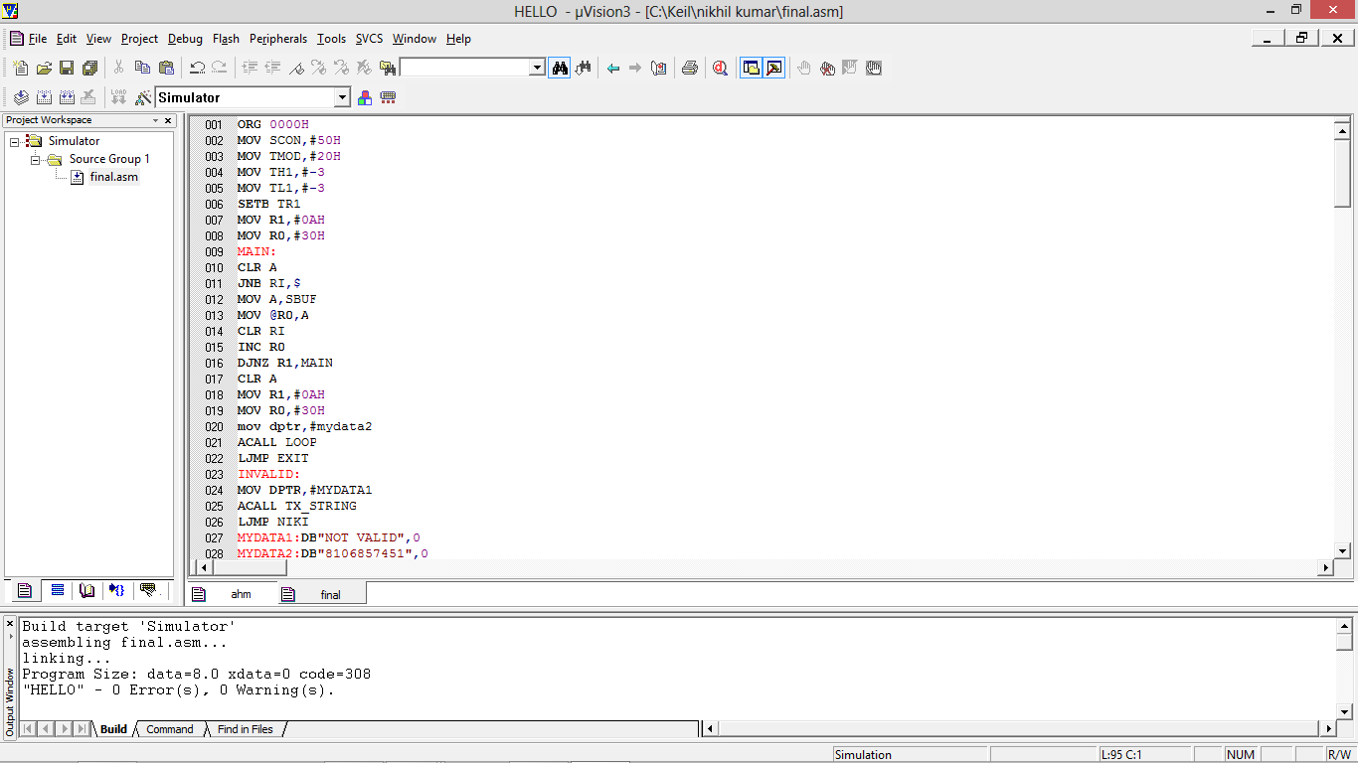

23. If the file contains no error, then press Control+F5 simultaneously.

24. The new window is as follows.

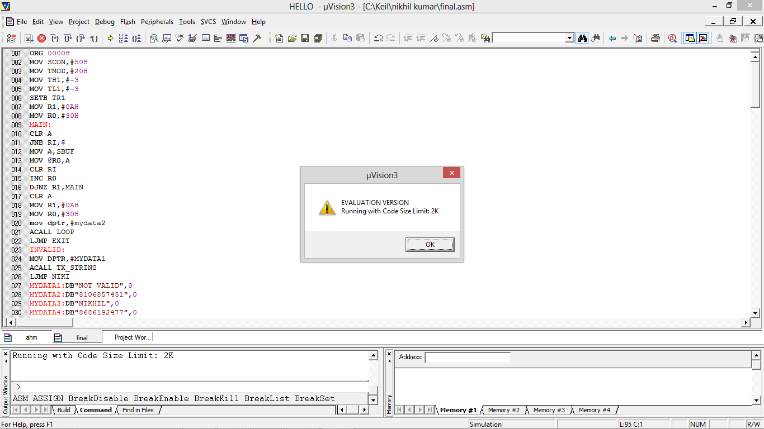

25. Then Click “OK”.

26. Now click on the view from menu bar, and check your required serial as shown in fig below.

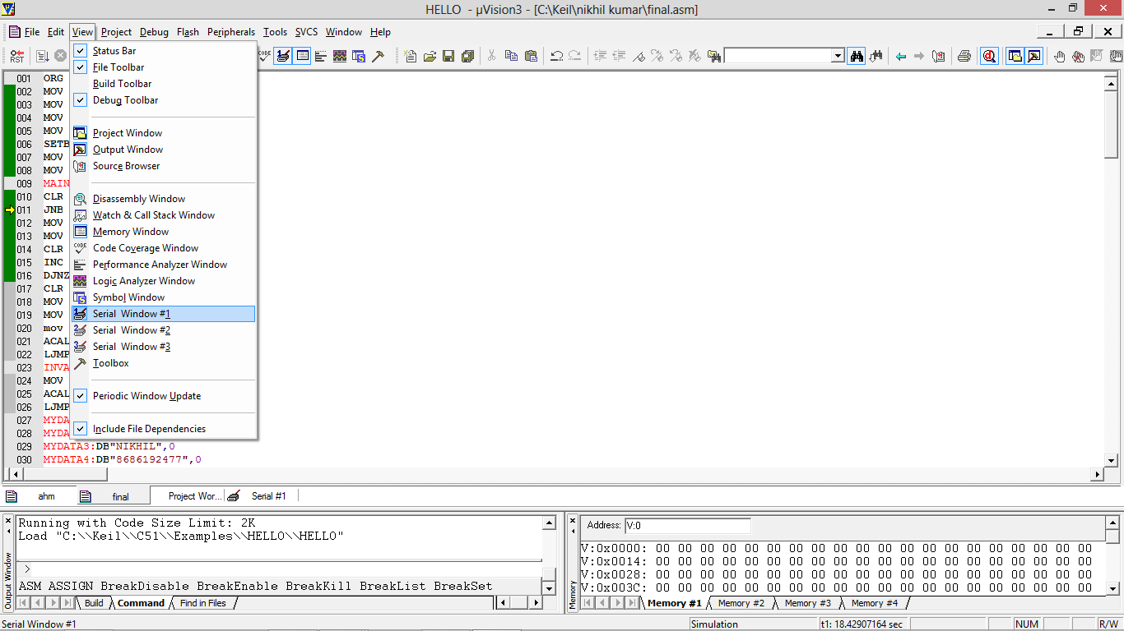

27. Now press F11 key slowly at some point the cursor stays constant then give input in the serial port which is not visible.

28. Then again press F11 slowly finally you will find output in the same serial port.

29. This indicates you are running program successfully.

**CHAPTER-7**

**MOBILE APPLICATION**

**This project requires an android application to monitor and c**

we designed this android application by using ECLIPSE SOFTWARE

This is a user-friendly android application.

Registration has to be done for one time.

We must login (offline) in the application to trace the vehicle.

**LOG-IN AND REGISTRATION PAGE**

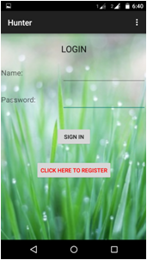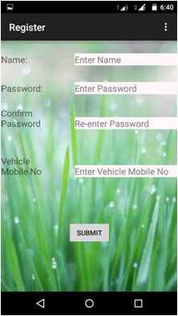

These images are the screenshots to show the registration and login process.

This application is an offline application.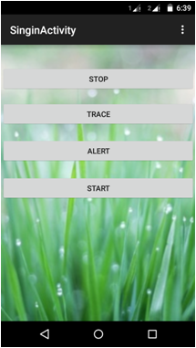

Once we login into the application,

we can see the options there,

i.e., START, STOP, TRACE and ALERT.

We can select what we want to do

respectively.

**TRACE**

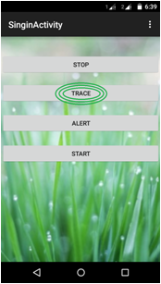



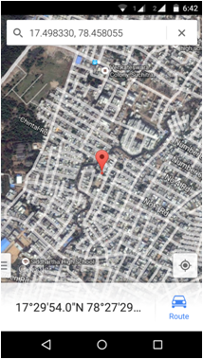

The location of the vehicle will be shown in Google maps.

**ALERTING**

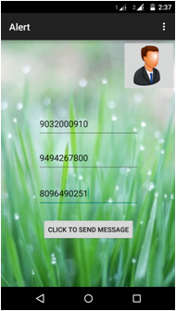

We can send alert

message for 3

numbers at once.

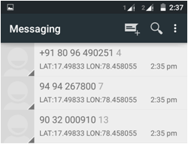

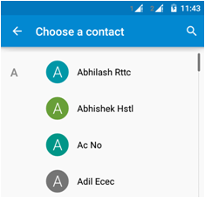

The numbers can also be selected from the contacts.

This will be very **important** because if we’re **not available** at the **time of the theft**, an alert can be sent to the people from anywhere.

We can even START and STOP the vehicle, and also give ALERTS to the people around from our contact list.

**STOP AND START**

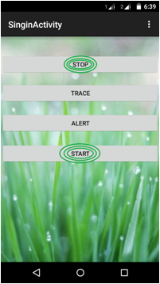

The START and STOP buttons here are used to start and stop the vehicle through the application.

After stopping the vehicle by using this, an alarm will start blowing till start message is sent to it.

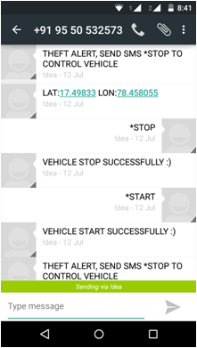

This is how the messages will be in background.

**CHAPTER-8**

**8.1. TEST CASES**

**Steps for testing the circuit board:**

1. The circuit is first connected to pc by using a db-9 connector port placed on pcb for testing the circuit using serial communication instead of directly applying to the application device.
2. The power supply to the circuit board is given through the power socket up on the pcb the led connected to this power socket the glow of led ensures us the working of power socket.
3. The connections of microcontroller base is ensured by shorting 10 & 11 pins of IC base which functions as TXD and RXD pins and the input given through the key board appears at the serial communication window.This tells the proper functioning of IC.
4. Now the functioning of max232 is tested by shorting the TXD & RXD pin of max232 base i.e.13 & 14 pins. While testing this a sample program is dumped in to microcontroller and placed up on the controller IC base. The input given through keyboard the output is seen on serial communication window with respect to the sample program. Now we can say the whole controller kit is tested.
5. Sometimes the output may not be obtained at the serial window. This is caused due to electrical wiring problem in the PCB sometimes the internal wiring coincides of their may not be a connection between them then external wiring should be done.
6. The output may not be obtained due to improper placing of microcontroller on its base while testing.
7. After ensuring the working of the kit the program developed for specified operations to be done according to the project is dumped in to the microcontroller and the max 232 is also placed on its base.
8. The power supply to the kit is provided through the power socket.
9. The circuit board is supplied with the power through power socket.
10. The application device i.e. either bulb or any electronic device is attached at the relay switch.
11. The kit is placed in the dark room then the light sensor (LDR) detects the intensity of light in the room.
12. Then according to the program dumped in the microprocessor the output is given by the controller.
13. This output is given to ADC by the controller.

**8.2. APPLICATIONS AND ADVANTAGES:**

**APPLICATION:**

1. Stolen vehicle recovery.
2. It is used for food delivery and car rental

Companies.

1. It is used in military, navigation, automobiles, air-crafts, fleet management, remote monitoring,

Remote control, security systems, teleservices, etc.

**ADVANTAGES:**

1. It provides more security than other system.
2. From the remote place we can access the System.
3. Automatic engine locking.

**8.3. RESULT ANALYSIS**

We a team of 4 members have successfully completed our Project on Tracking Down Vehicle and Locking it remotely using GPS and GSM technologies.

We first tried to understand the working of our project through the schematic and then we proceeded to build the circuit as per the schematic. Initially we faced few problems with the GPS modem, as it won’t work efficiently inside buildings. And also the GSM modem suffered problems with the coverage area of the Mobile Service Provider. So, we used Airtel as it has maximum coverage area. In order to solve this problem we can use dedicated servers and purchasing satellite space so that we can track down the vehicle anytime and anywhere.

The overall developed circuit looks as in the following figure:

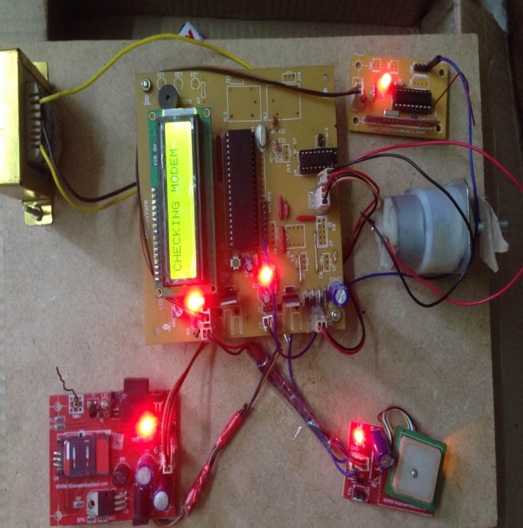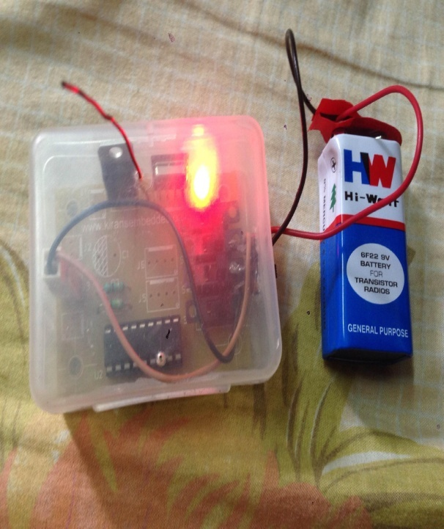

**Transmitter Receiver**

**Figure8.1: Picture of GPS AND GSM BASED VEHICLE TRACKING AND THEFT CONTROL SYSTEM kit.**

The above circuit works mainly by receiving messages from a mobile phone. There are three messages/commands by which we can track and control the vehicle. They are,

i) POSITION

ii) LOCK

iii) UNLOCK

i) **POSITION:** Initiates the GPS modem and receives the Latitude and Longitude position and this information will be sent to the mobile from which it received the message.

ii) **LOCK:** When this message is sent, then the Microcontroller initiates the engine motor to stop and which in turn stops the vehicle.

iii) **UNLOCK:** This command makes the motor to start again so that the vehicle starts running.

**8.4. CONCLUSION:**

This project deals with the design & development of a vehicle tracking and theft control system for an automobile, which is being used to prevent or control the theft of a vehicle. The simulation of the circuit design and its implementation is done using KEIL software. This system is designed to improve vehicle security and accessibility. With the use of wireless technology vehicle owners are able to enter as well as protect their automobiles with more passive involvement. Vehicle Tracking System resulted in improving overall productivity with better fleet management that in turn offers better return on your investments.So in the coming year, it is going to play a major role in our day-to-day living.

In our project the security system is based on embedded control which provides security against theft. The GSM modem provides information to the user on his request. The owner can access the position of the vehicle at any instant. He sends a message in order to lock the vehicle. The GPS receiver on the kit will locate the latitude and longitude of the vehicle using the satellite service. This is reliable and efficient system for providing security to the vehicles through GSM,GPS and serial communication.

**8.5. FUTURE SCOPE:**

Ideally, this project could be made more convenient and secure with the use of satellite modems instead of cell phones as tracking device as the system may fail when there is no network coverage. This design can be made more enhanced in future to support camera, handset phone / hands free, mobile data LCD display, web based tracking software, and also PC based stand alone software.

We can use the EEPROM to store the previous Navigating positions up to 256 locations and we can navigate up to N number of locations by increasing its memory. We can reduce the size of the kit by using GPS+GSM on the same module. We can increase the accuracy up to 3m by increasing the cost of the GPS receivers. We can use our kit for detection of bomb by connecting to the bomb detector. With the help of high sensitivity vibration sensors we can detect the accident. Whenever vehicle unexpectedly had an accident on the road with help of vibration sensor we can detect the accident and we can send the location to the owner, hospital and police. We can use our kit to assist the traffic. By keeping the kits in the entire vehicles and by knowing the locations of all the vehicles.

**BIBLIOGRAPHY:**

1. Chen, H., Chiang, Y. Chang, F., H. Wang, H. (2010). Toward Real-Time Precise Point Positioning: Differential GPS Based on IGS Ultra Rapid Product, ICE Annual Conference, The Grand Hotel, Taipei, Taiwan August 18-21.
2. Asaad M. J. Al-Hindawi, Ibraheem Talib, “Experimentally Evaluation of GPS/GSM Based System Design”, Journal of Electronic Systems Volume 2 Number 2 June 2012.
3. Kunal Maurya, Mandeep Singh, Neelu Jain, “Real Time Vehicle Tracking System using GSM and GPS Technology- an Anti-theft Tracking System,” International Journal of Electronics and Computer Science Engineering. ISSN 2277- 1956/V1N3-1103-1107.
4. Vikram Kulkarni & Viswaprakash Babu, “embedded smart car security system on face detection’, special issue of IJCCT, ISSN (Online):2231-0371, ISSN (Print):0975- 7449, volume-3, issue-1.
5. National Crime Records Bureau, Ministry of Home Affairs, Government of India.
6. V.Ramya, B. Palaniappan, K. Karthick, “Embedded Controller for Vehicle In-Front Obstacle Detection and Cabin Safety Alert System”, International Journal of Computer Science & Information Technology (IJCSIT) Vol 4, No 2, April 2012.
7. [www.mitel.databook.com](http://www.mitel.databook.com)
8. [www.atmel.databook.com](http://www.atmel.databook.com)
9. [www.wikipedia.com](http://www.wikipedia.com)
10. [www.flashmagictool.com](http://www.flashmagic.com)